**CS3960 AI**

5 trends

* Ubiquity
  + Put computing/processing power into places + devices
  + Processing capability spreads = sophistication = ubiquitous
* Interconnection
  + Computing as process of interaction
  + Large distributed/concurrent system
* Intelligence
  + Complexity of tasks, that can automate/delegate
* Delegation
  + Giving control to computers (w/o intervention) in safety-critical tasks
* Human orientation
  + Machines grow towards human uds
  + More human-orientated = abstraction

Delegation + intelligence = need to build computer sys that can act on behalf

Imples:

* Ability to act independently
* Acts in best interests of (human/systems)

Interconnection + Distribution = core of comsci

Implies:

* Systems can cooperate + reach agreements (or compete) with other systems

**Agent = com sys capable of independent action in env, in order to achieve goals** (figuring out what to do to satisfy design objectives instead of being told)

**Agent = intentional system with mental states (beliefs, desires, intention)**

**Agent = 3 types behv (reactive, proactive, social)**

Mutli agent = interact with one-another (ability to cooperate, coordinate, negotiate)

2 key problems

* Agent Design – independent autonomous
* Society Design - interaction
* Micro/macro view

Paradigm = for SE, understanding human societies

Distributed/concurrent systems = agents autonomous, making decisions (nneed sync + coord)

AI = metaphor for integrating AI (reasoning, planning, learning)

Economics/Game theory = descriptive concepts.

But focus = computational, resource bounded agents

Social science = can draw insights (inspiration, cross-fertilization, but not subsumption)

Intelligent Agents

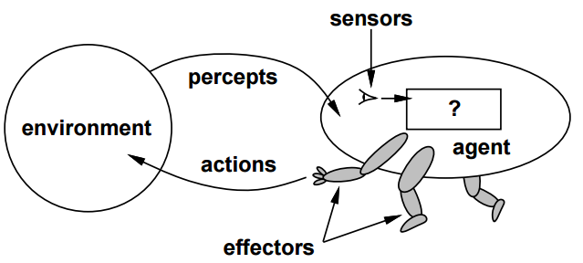

* Agent in env
* Perceives env + acts
* Interaction = ongoing, non-termniating
* VIEW of agent = env (other agents)

Perceive – decide – act - Perceive – decide – act - …

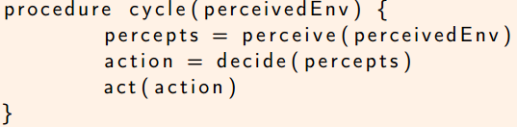

ENV = state, set of agents, update func, termination func

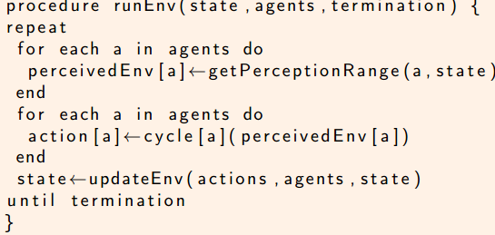

**Reactive**

* Required, env = dynamic
* Ongoing interaction with env

**Proactive**

* Do things (achieve goals)
* Goal directed behaviour
* Generating + attempting to achieve goal
* Take initiative

**Social**

* World= multi-agent
* Some goals = require interaction
* Cooperation + coordination + negotiation
* Ability to communicate

**Mobility, veracity, benevolence, rationality, learning**

**Objects VS Agents**

* Encap state
* Comm via message passing
* Have methods, corresponding to ops (performed on state)
* Agents = autonomous (decide themselves)
* Smart, flexible behaviour
* Active, not service providers

**VS Expert System**

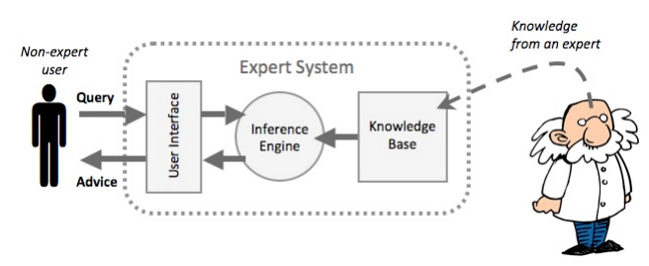

* Disembodied expertise
* Expert advice (giving symptoms, answering questions)
* Expert = Not aware of aware of world
* Expert does not actively act/monitor env

**VS AI**

* No need to solve all problems of AI = for agent
* Agent = limited env

**ACCESSIBLE VS INACCESSIBLE**

* Accessing info about environment state
* More accessible = simpler to build (physical world, internet = inaccessible)

**DETERMINISTIC VS NON-DETERMINISTIC**

* D = Any action = single guaranteed effect (no uncertainty)
* non-deterministic = physical world (greater problems)

**EPISODIC VS NON-EPISODIC**

* E = perf of agent = dependent on discrete E (no link of performance in diff E)
* E = Regardless of previous decision
* NE = decision = affect future decision
* NE = short term actions = long term conseq
* E = simpler

**STATIC VS DYNAMIC**

* Static = remain unchanged except actions of agent
* Dynamic = change beyond agent’s control

**DISCRETE VS CONTINUOUS**

* Discrete = ( fixed, finite number of actions, and precepts)
* Chess = discrete, taxi driving = continuous

**VACUUM (PEAS analysis)  
P**erformance req, for **E**nv, using **A**ctuators and **S**ensors to access environment 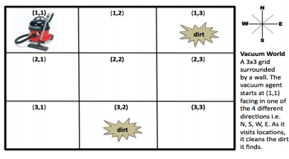

* 4 states (NSEW)
* m*n grid, states = 2m*n possibilities
* Env = 4 * (m * n) * 2m*n states (3*3 = 18432)

**Percepts**

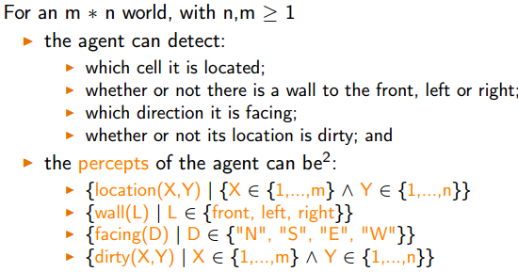

**Actions**

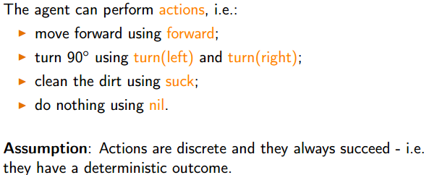

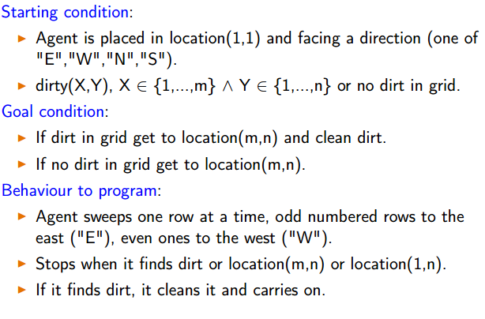

**TILE WORLD**

* Dynamic hole change (simulate dynamic env)

**Agent as Intentional System:**

* Took umbrella = believe might raining = wanted to stay dry
* Wanting, believing, hoping, fearing…

Describes entities, where BEHAVIOUR = predicted by belief/desires/rational acumen

* First order (has belief/desire, no belief/desire about belief/desires)
* 2nd order (more sophisticated) has belief/desire about belief/desire of others)

e.g. LIGHT SWITCH = cooperative agent

- capability of transmit at will

- transmit when it believes we want it transmit, not otherwise

- flicking the switch=our way of communicating desire

BUT knowing it DOES NOT BUY US ANYTHING (we understand the mechanism) MORE we know about system = LESS we rely on intentional explanation

COMPLEX = explanation of behaviour = not practical

* Need more abstractions/metaphor

Abstractions = impt dev in computing

* Objects, procedural abstractions, ADT

AGENT = powerful ABSTRACTION

* Convenient/familiar way of describing/explaining/predicting BEHAVIOR of complex systems.

Adv = Characterising agents, nested representation (of other sys)

**POST declarative system**

* **Procedural** (say exactly what a sys do)
* **Declarative** (say what we want to achieve, let inbuilt control mechanism figure out)

**Abstract Architecture for Agents**

* **States**(finite set, discrete, instantaneous)
* **Possible actions available** (transform E state)
* **Run r**  (env = seq of interleaved env states/actions)

**Run R** = set of all possible finite seq (over E and Ac)

**RAc** = ends with an action  
**RE** = end with an environment state

State transformer function = 

Env often = hist dependent, non-deterministic

 **=** ended

Env = triple (Environemnt, initial state, transformer F 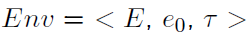

Agent function = maps runs to actions

Makes **decision** about action based on hist



**System (**pair containing agent, env)

System = assoc with set of possible runs R(Ag, Env)

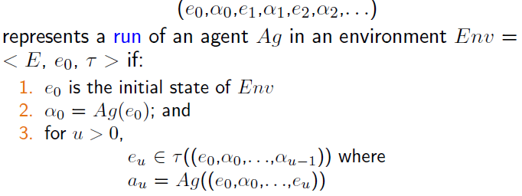

**Purely Reactive Agent**  = no reference to history

**e.g. thermostat**

**Perception System**

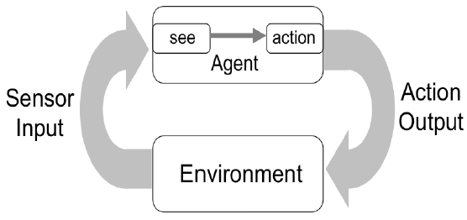

See = observe environment (set percept)



Action = take percepts into action

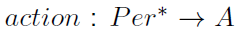

**Maintain State**

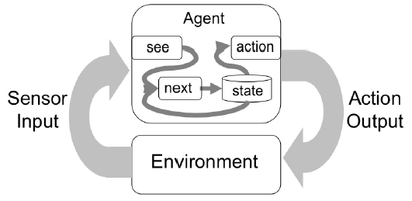

Internal state of agent (to be maintained)

See func = unchanged

Action func = internal state to action

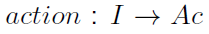

Next func = internal state X percept -> internal state



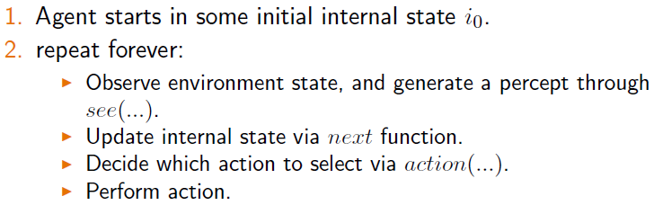

Non-deterministic env = update state after action

**Tasks**

* Top level goal
* Specified, agent must adopt as goal
* Say WHAT without HOW
* Goal = binary distinction (not suitable for performance)

**Task specification = function**

Associate utilities with individual states

real number with E state

Value of RUN? Hard

Disadv = hard to specify long term (**discount** for state)

Associate utilities with RUN (long term view)

Hard = numbers from? Hard to formulate task, well for some scenario.

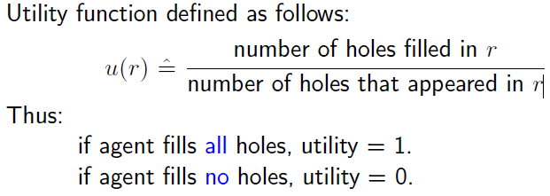

Maximizing expected utility (using decision theory)

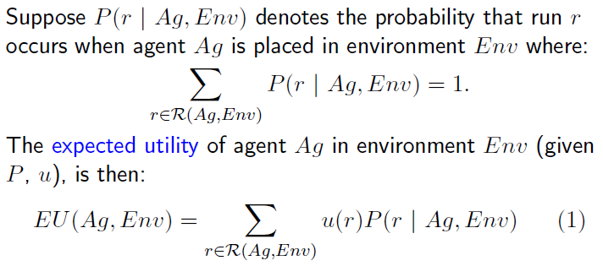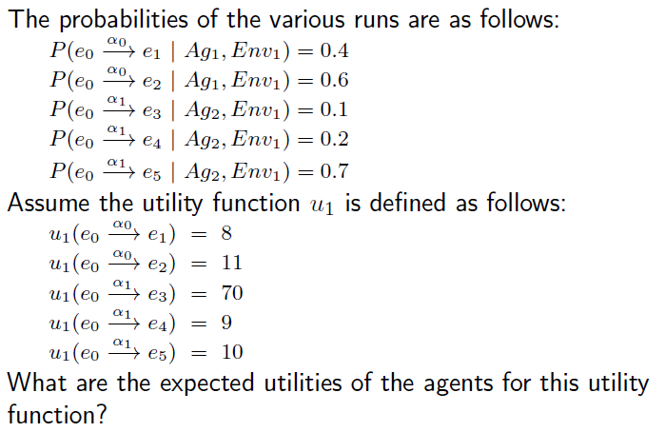

Optimal = maximizes expected utility (not best, on avg best)

Important = transform global criterion of rationality (performance over environment histories)

Bounded Optimal Agent (can be implemented on machine)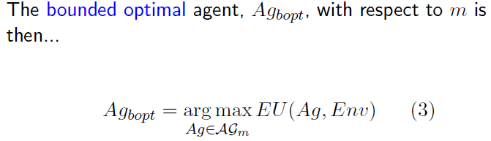

Predicate Task Specification

Run = 1 (true) 0 (false)

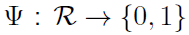

Task Environment

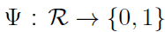

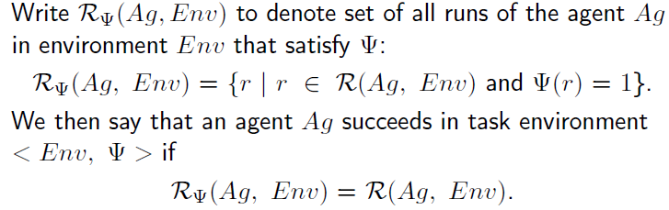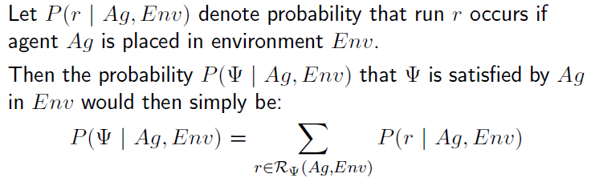

Achievement tasks (achieving goal)

* Set of good or goal states
* Succeeds if at least one states guaranteed
* All considered equally good

Maintenance tasks (maintain current state)

* Set of bad states
* Succeeds if avoid all states
* All considered equally bad

**Agent Architecture**

**=** software design for agent

Top level: percept – state – decision – action

Defines:

* Key data struct
* Operations of data struct
* Control flow between ops

**Symbolic Reasoning Agent > Reactive Agent > Hybrid Agent**

**Symbolic Reasoning AI**

* View them as knowledge based
* Symbolic AI
* Build on top of expert sys idea
* Contains symbolic model of world
* Makes decision via symbolic reasoning

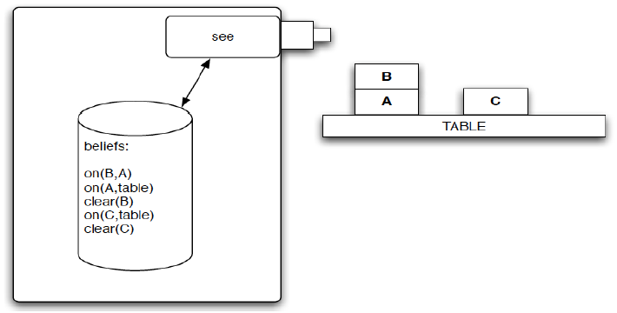

**Problem = translate real world** into accurate symbolic

e.g. vision, speech, learning

= **symbolic represent info about real-world entities/process** e.g. knowledge, automated reasoning/planning

**Deductive Reasoning Agent**

**Logic to encode theory** FOR **best action** to **perform in ANY situation**

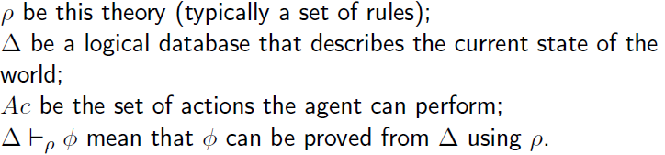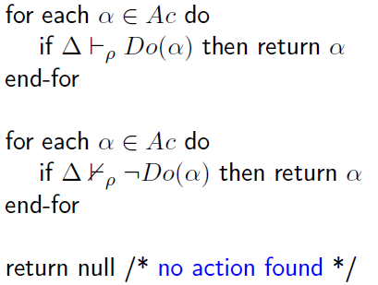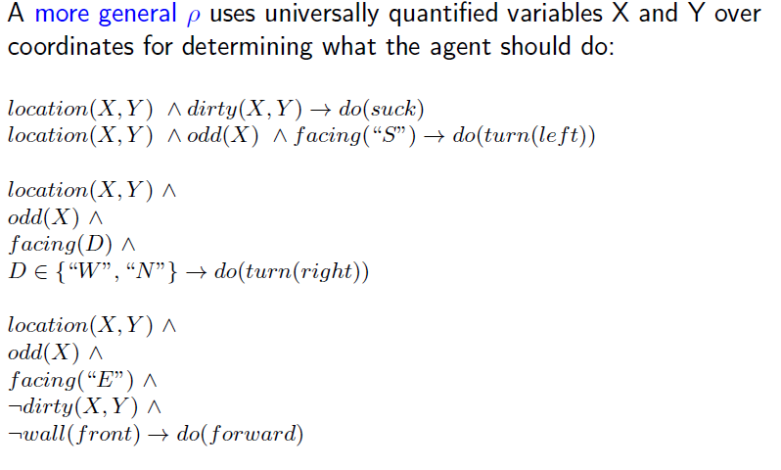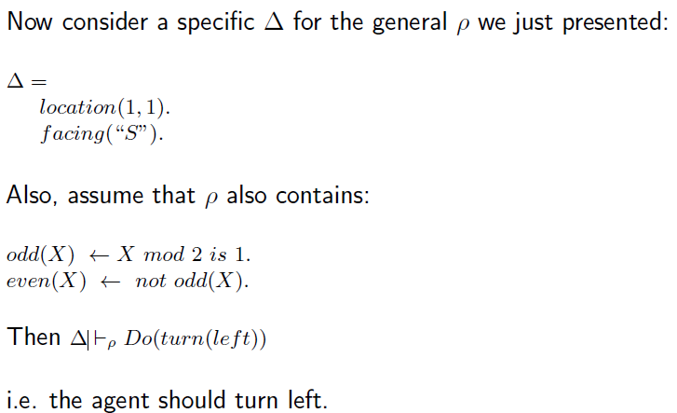

**Agent Oriented Programming**

* based on **societal view**
* specialisation of OOP (actors variant, async comms)
  + fixes form of agent state
  + fixes form of message
  + constraints on methods

Complete AOP system

* **restricted formal language** (clear syntax/semantics)
* **interpreted programming language**
* **agentifier** (convert neutral device into programmable agents)

KEY IDEA

* program in BELIEF, COMMITMENT, INTENTION

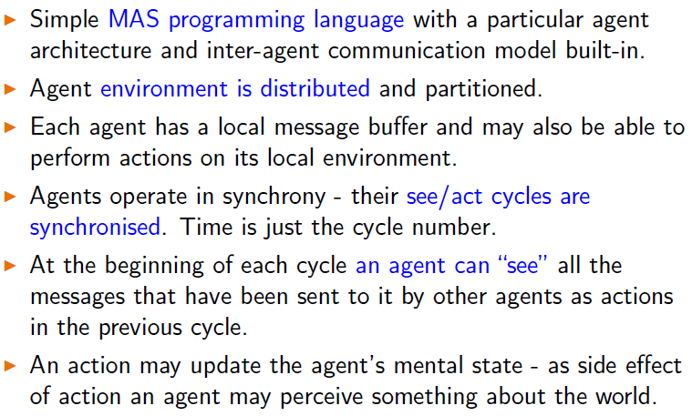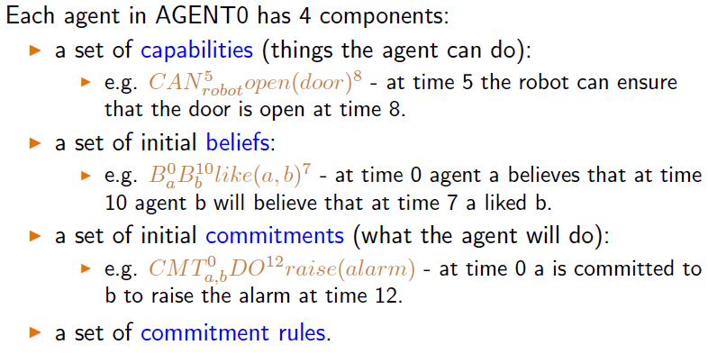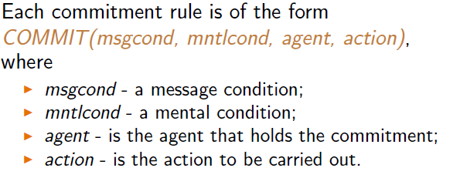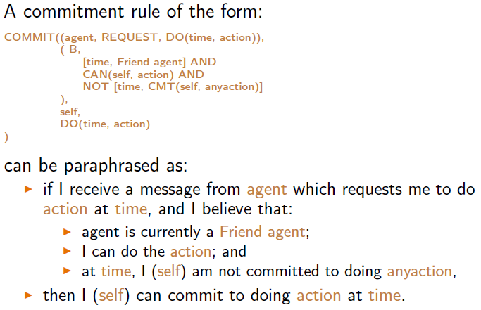

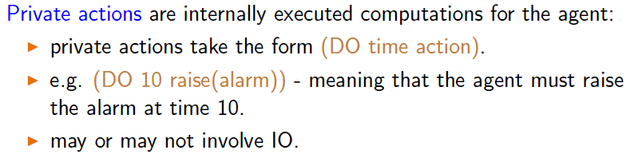

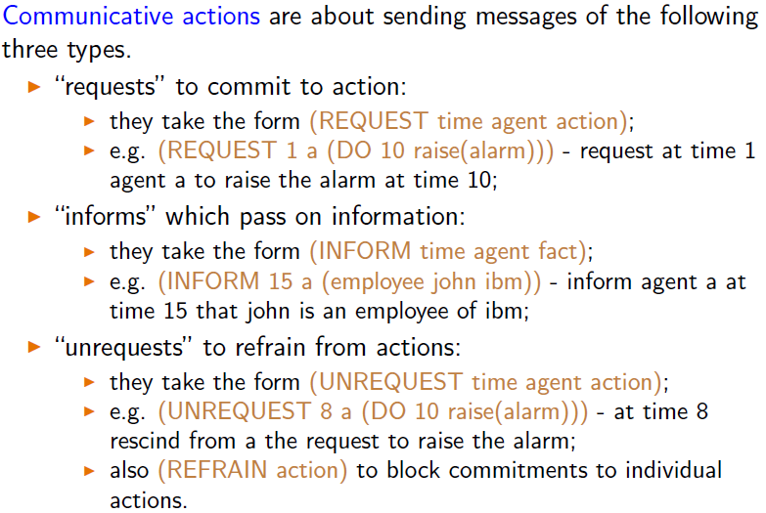

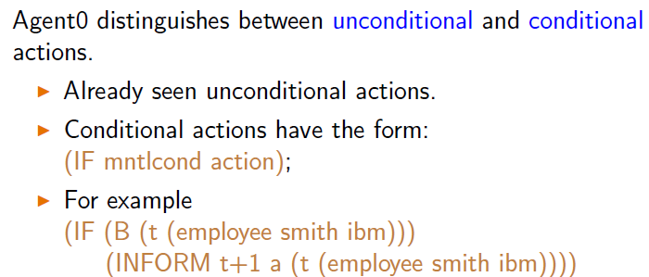

See-decide-act style

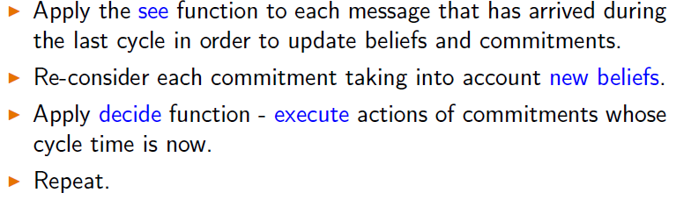

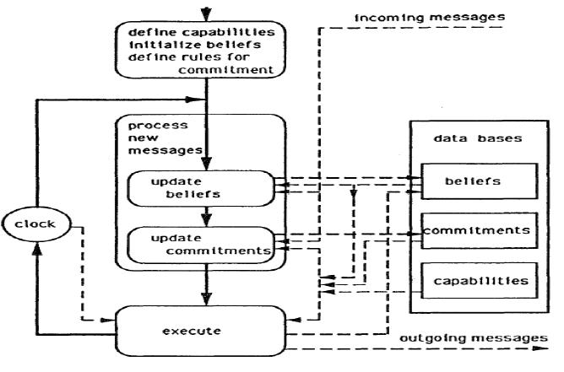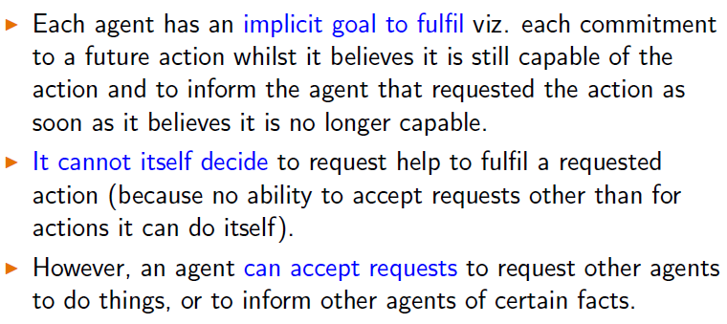

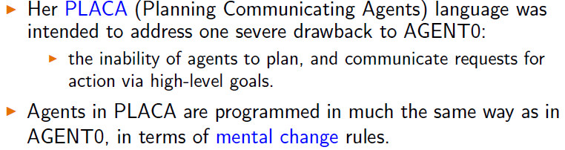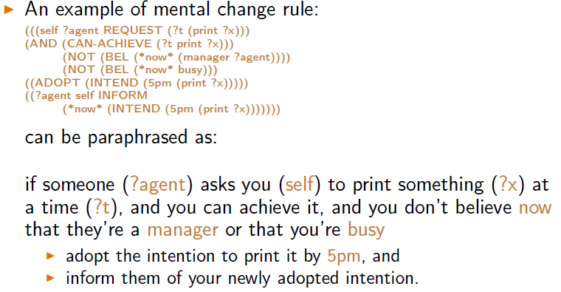

**Practical Reasoning Agents**

Belief-Desire-Intention model of human practical reasoning

**Belief**

* informational state of agent
* inference rules (forward chaining to new beliefs)
* not knowledge, may not be true
* belief base (stored in base, implementation)

**Desires**

* motivational state of agent
* goals (like to accomplish)
* active desires must be consistent (cant have conflicting goals)

**Intentions**

* deliberative state
* desires that agent is committed to
* **PLANS** are actions to perform >=1 intentions

**Events**

* triggers for reactive activity
* MAY update beliefs, trigger plans, modify goals
* MAY generate externally, Received by sensors/integrated systems
* MAY generate internally, to decouple updates/ plans of activity

**Practical Reasoning**

* directed towards actions
* weighting conflicts considerations/options
* **Theoretical reasoning**  = beliefs

**Deliberation**

* What state of affairs we want to achieve (output = intentions)

**Means-end reasoning**

* **How** to achieve states of affairs   
  (output = plans)

**Complications**

* **Resource bounds**
  + Avail memory
  + Time constraints
* **Implications**
  + Computation = impt resource, affects perf
  + Agents cannot deliberate indefinitely, need to commit to one state of affair (may not be optimal)

**Intention pose problems**

* Need to determine ways of achieve them (requires resources)

**Information provide a filter**

* Filter some intentions, must not conflict (cannot go pub)

**Agents track success**

* Inclined to try again if attempt fail
* Goals, sub-goals, Plans, sub-plans

**Agents believe their intentions**

* Are possible

**Agents do not believe they will not bring about** intentions

* It would be irrational to bring an intention that I think would fail

**Agents believe they will bring about** intentions

* If I intend, I believe (under normal circumstances) it will succeed

**Agents need not intend all expected side effects**

* If believe and intent <smt>, does not mean I intend the side effects when achieving <smt>
* **Side effect / package deal**

**Intentions can be dropped**

* When no longer achievable
* Something happens to prevent it
* Opportunity to satisfy a higher priority desire

**Plannning**

* Course of action = achieve desired goal
* Needs goals to achieve
* Needs to know possible actions
* Needs to know state of environment
  + Generates plan
* Auto planning

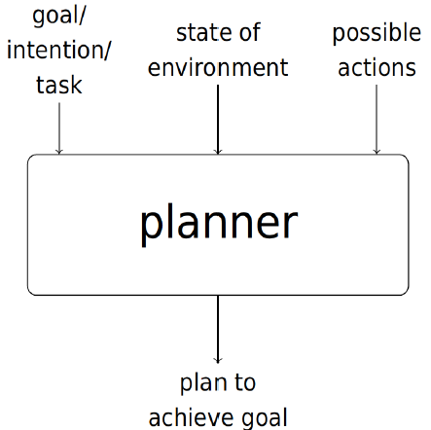

**Example**

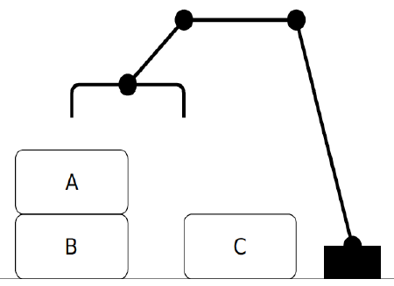

Environment = needs ontology

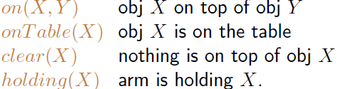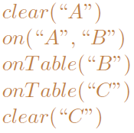

**Closed world assumption =** assumed to be false

**Goal state =** 

**STRIPS**

**Each action**

* **Name** : may have arguements
* **Precondition list :** list of facts must be true before action
* **Delete list** : list of facts no longer true after action
* **Add list** : list of facts made true after action

**Stack** action (places obj X it is holding on top of obj Y)

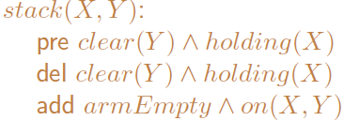

**Unstack** action (picks on obj X from obj Y)

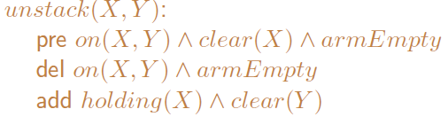

**Pickup** action (picks up obj X)

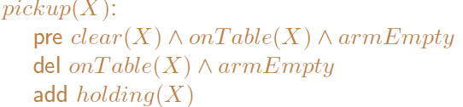

**Putdown** action (places obj X onto table)

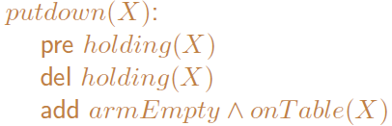

Plans = seq of action

Complex plans = more complex (while, if, else)

**Planning from first principles**

* Goal and intial state, constructs plan using STRIPS

**Plan libraries**

* Programmer specifies plans for specific goals in advance

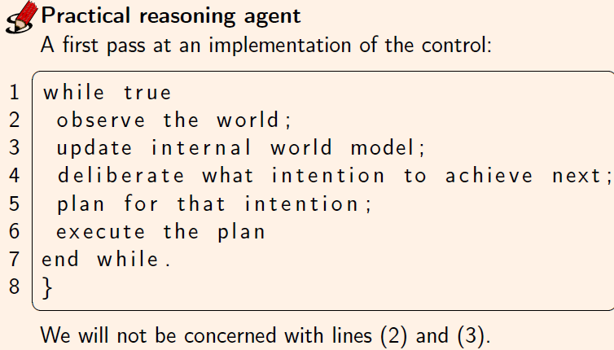

Deliberation, means end reasoning = **time cost**, hence, **world might change**

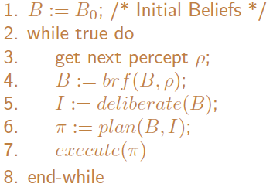

Deliberate =   
**uds-ing options  
choose btwn them  
commit to them**

2 distinct functions

* Option generation (seen as desires)
* Filtering (select the option) + commit

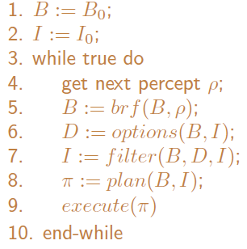

Degrees of commitment

* Blind commitment
  + Keep intention until achieved
  + fanatical
* Single-minded commitment
  + Keep intention until achieved
  + OR no longer possible
* Commitments BOTh to ENDS and MEANS
  + Replan if plan goes wrong
* 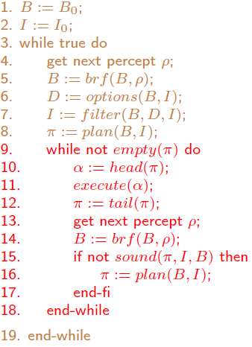
* NEED to stop and check if impossible

(single-minded commitment)

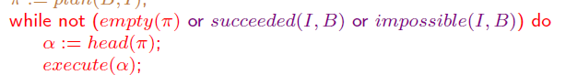

Intention reconsideration

* Gets to reconsider intentions every time around outer control loop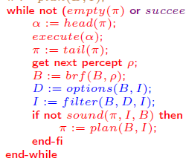
* BUT **costly (no time for action)**

Meta level control function (to decide whether to reconsider)

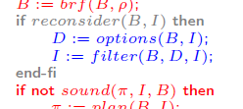

2 different types of reconsideration strategy

* BOLD agents (never pause to reconsider)
* CAUTION agents (pause to reconsider)
* Dynamism = rate of world change

Rate of change = low (bold is better)

Rate of change = high (cautious is better)

PRS (plan library) = procedural knowledge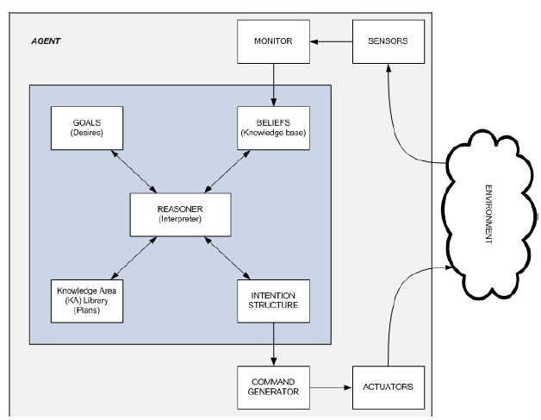AgentSpeak(L)

BDI style programming lang

* Belief store B
* Set of current intentions I
* Store of pending events E
* No separate desires
* Each agent own actions and plan lib

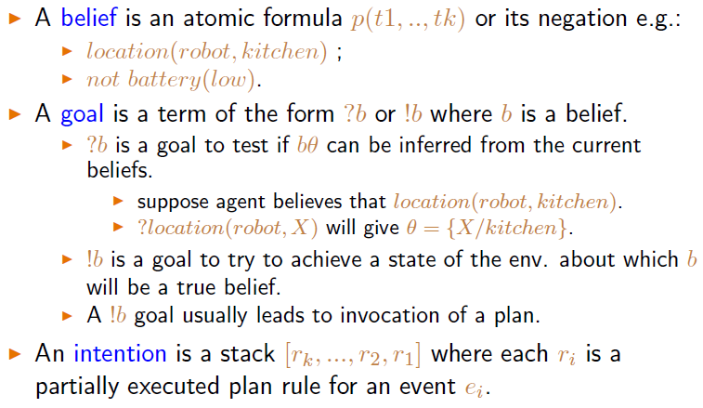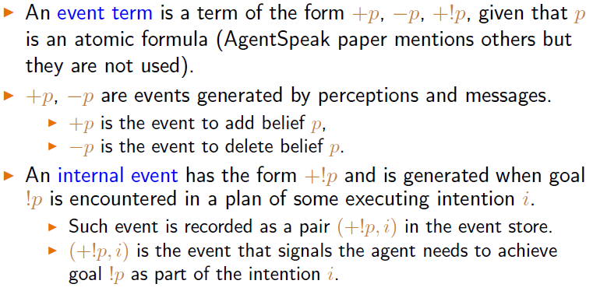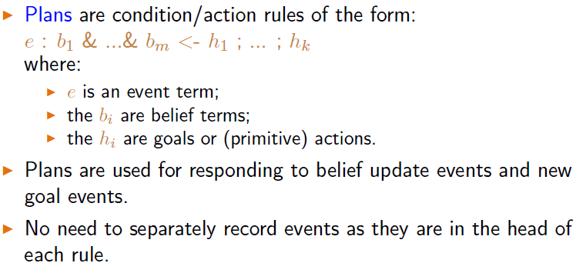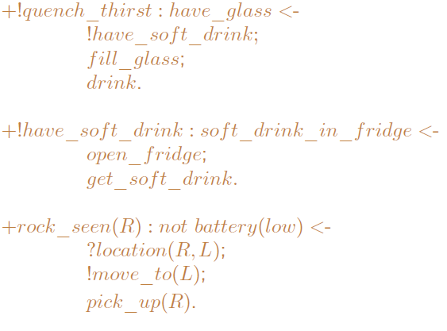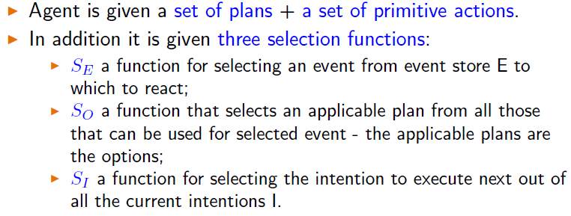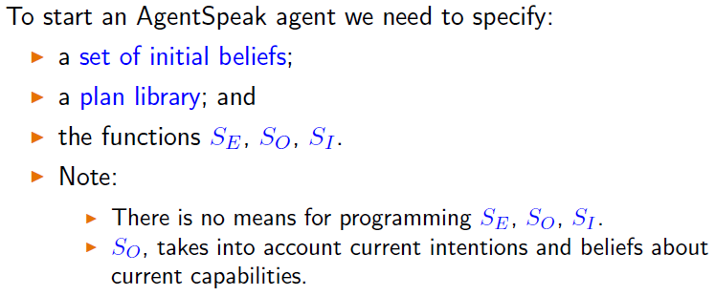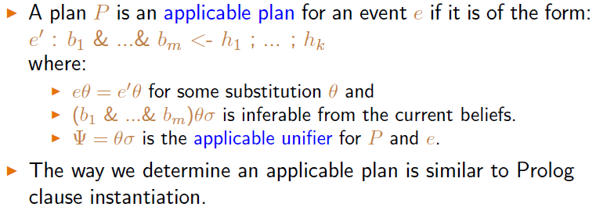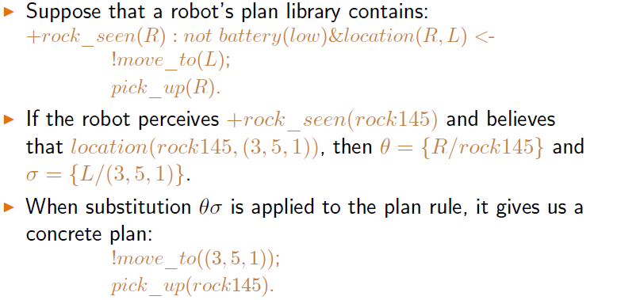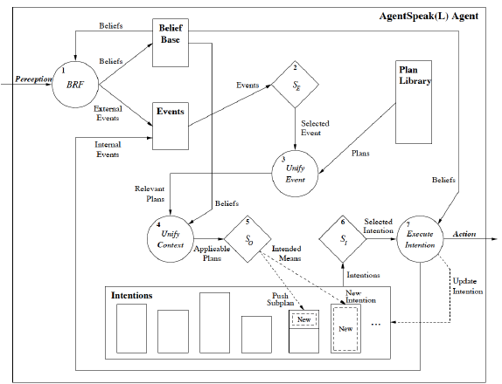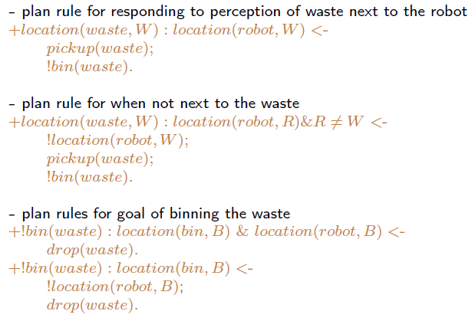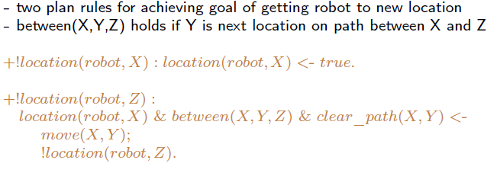Reactive Agent

Brooks (intelligence=):

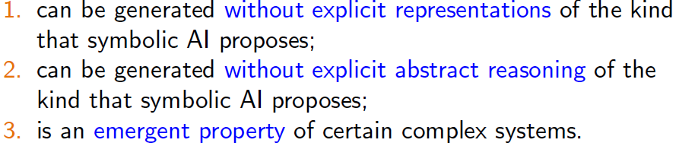

2 key ideas:

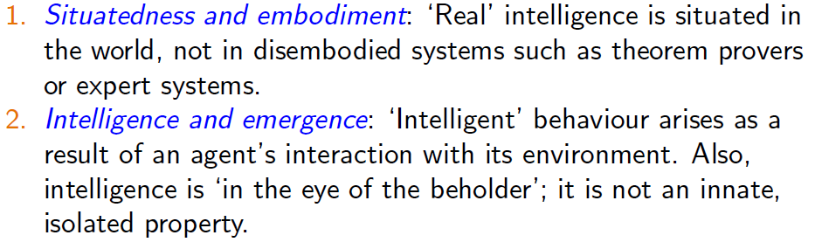

Subsumption Architecture

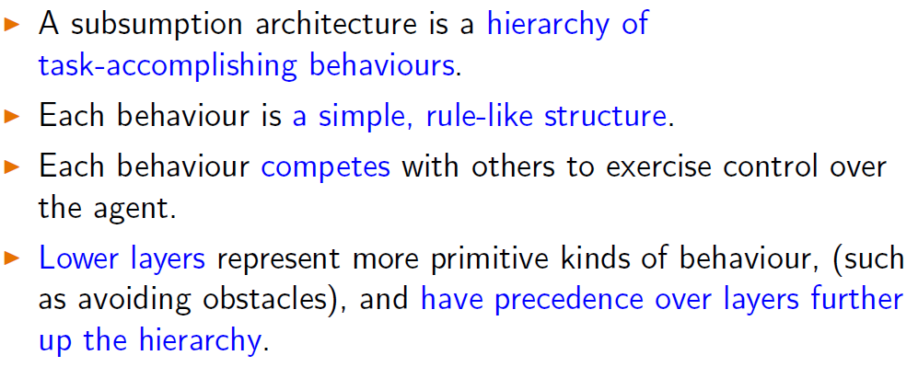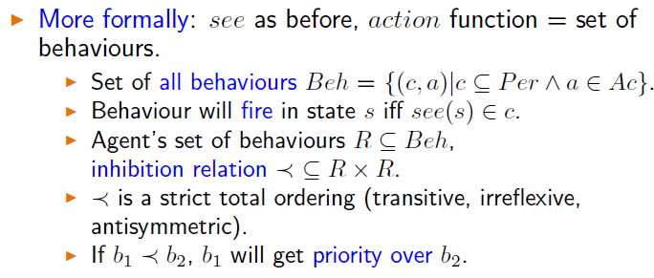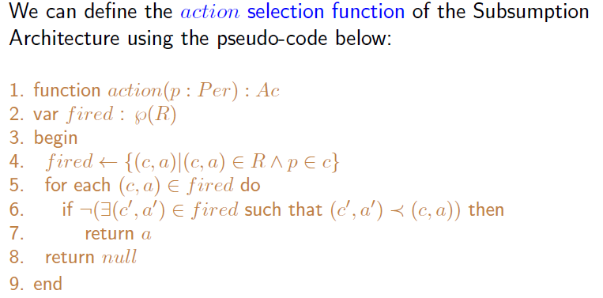

**Get the one with the higher priority**

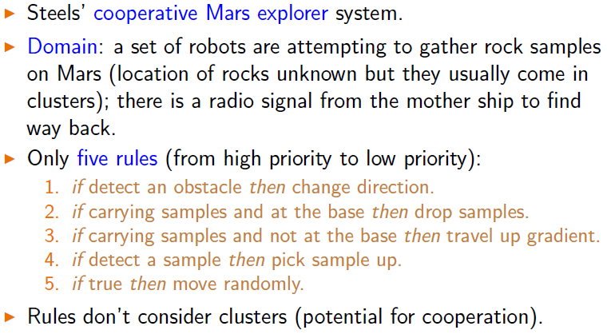

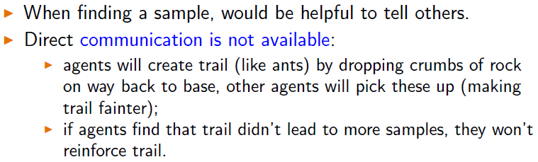

**Communication in that sense**

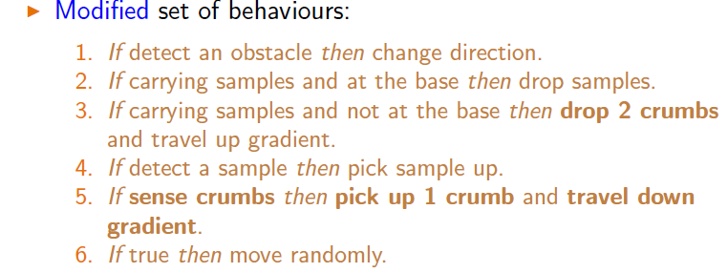

**Drawbacks**

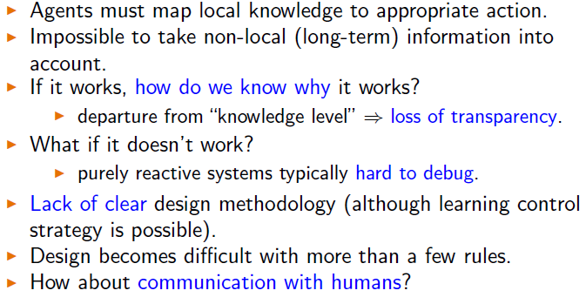

**Hybrid Architecture**

**Combine both perspective**

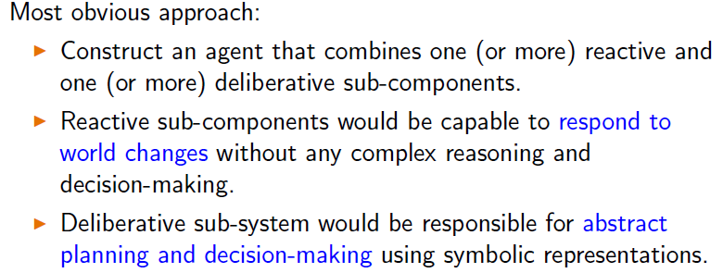

**Layered Approach**

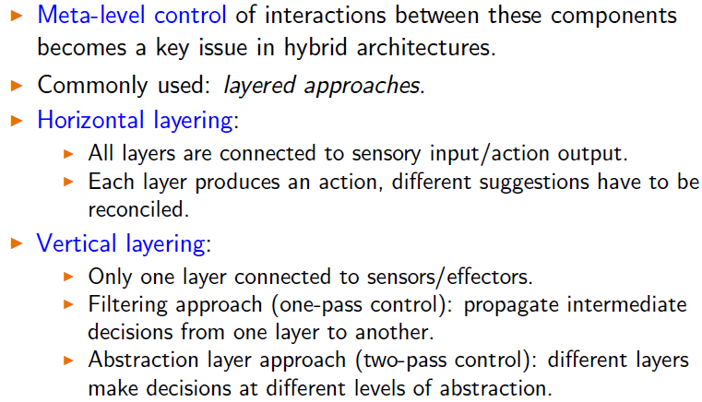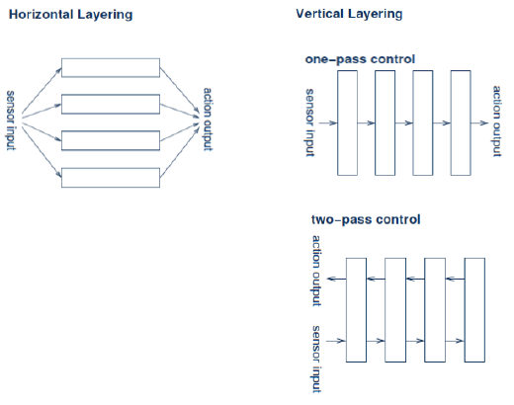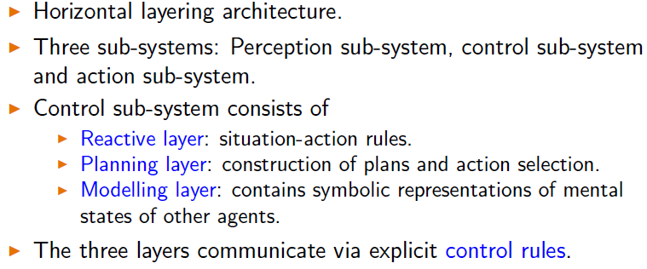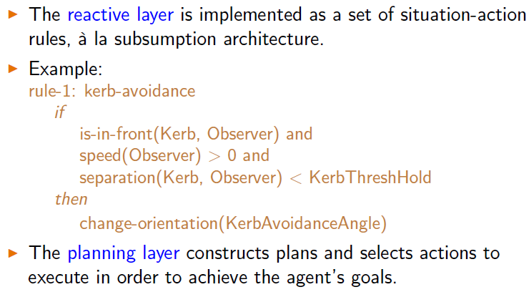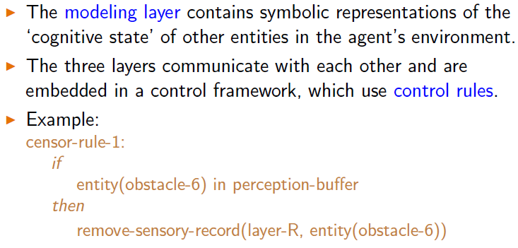

**Vertical  
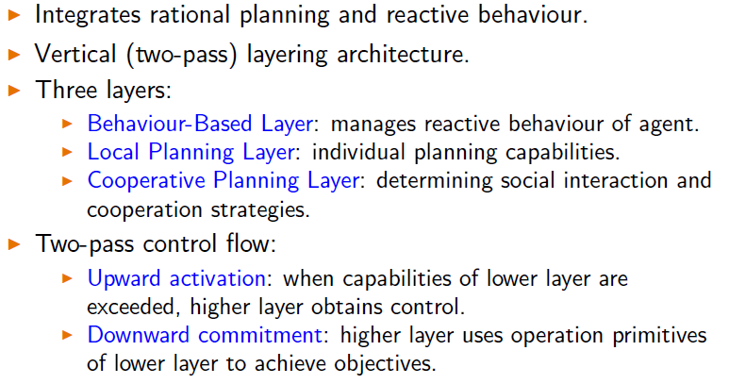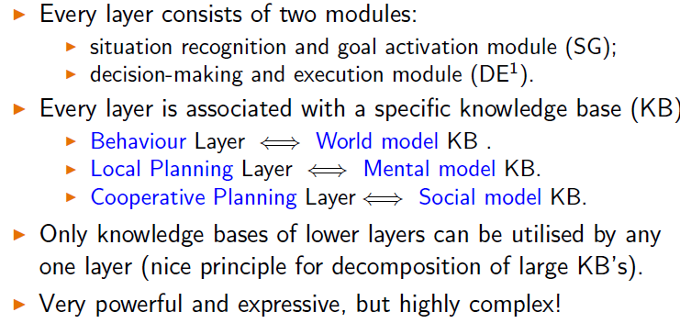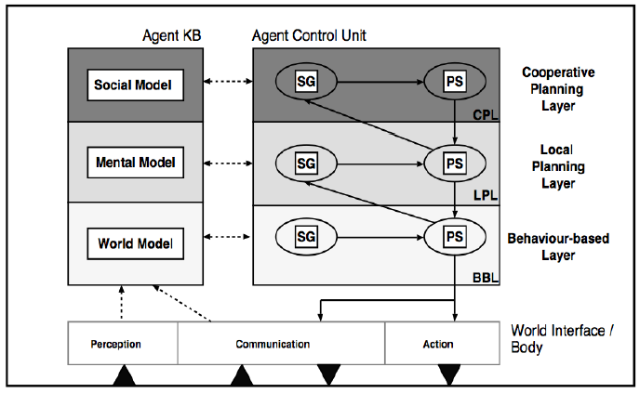**

**Summary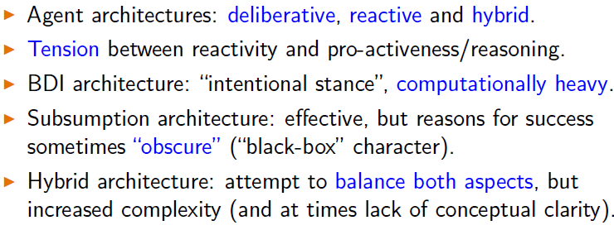Agent Communication**

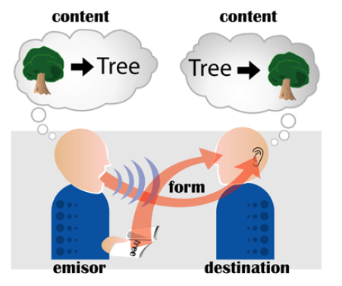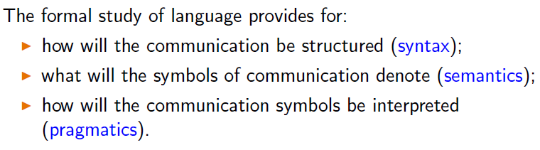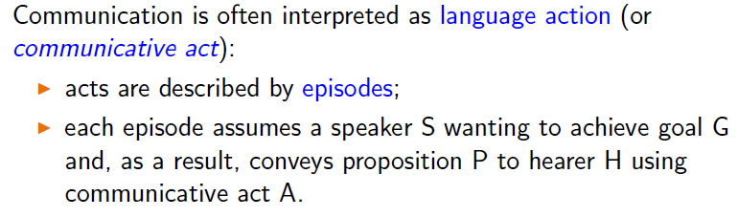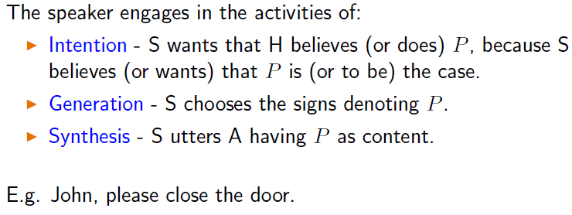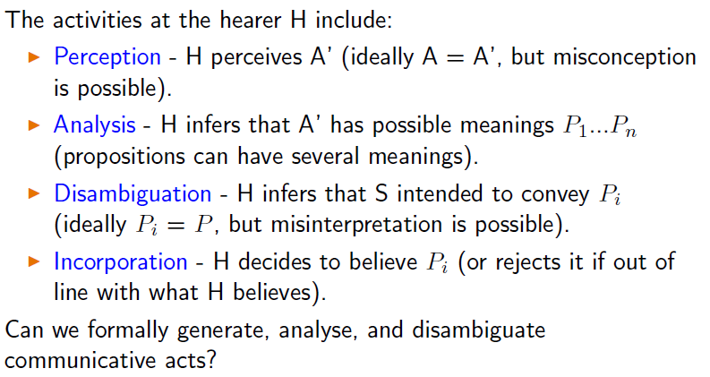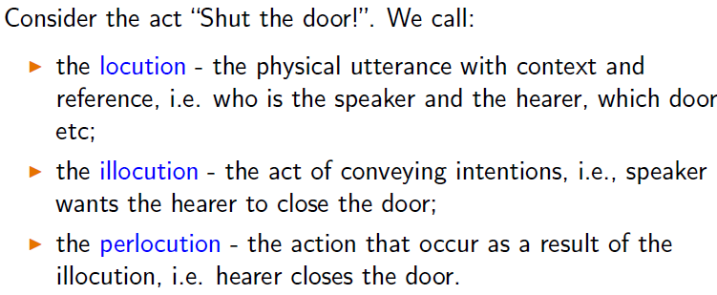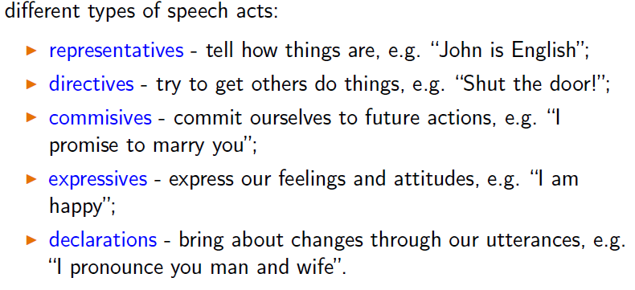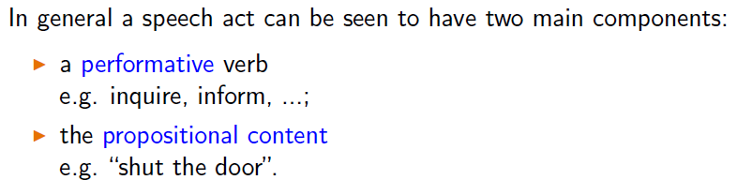

**KQML**

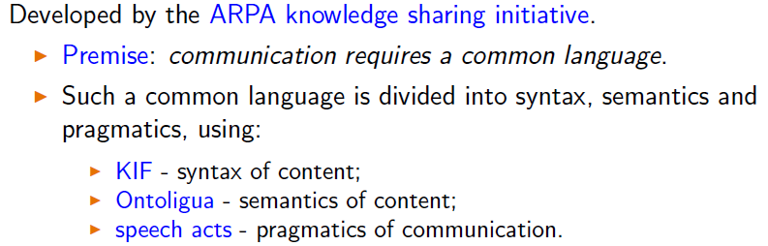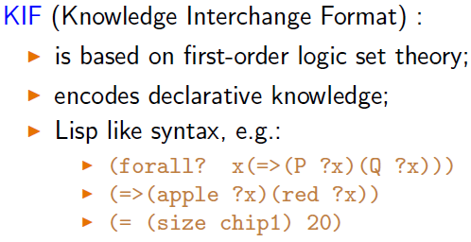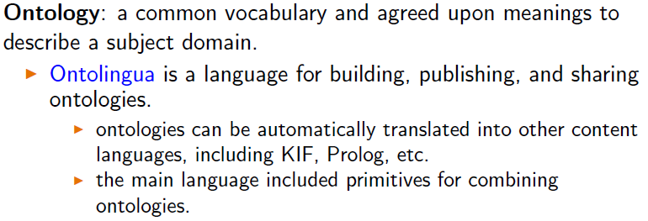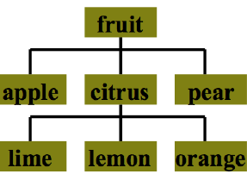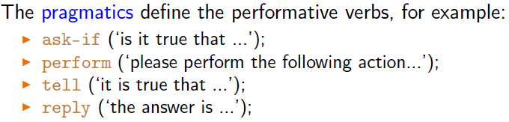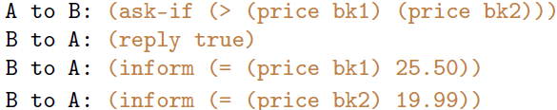

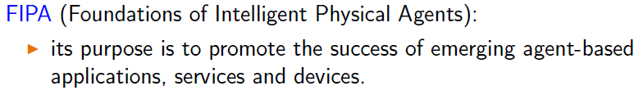

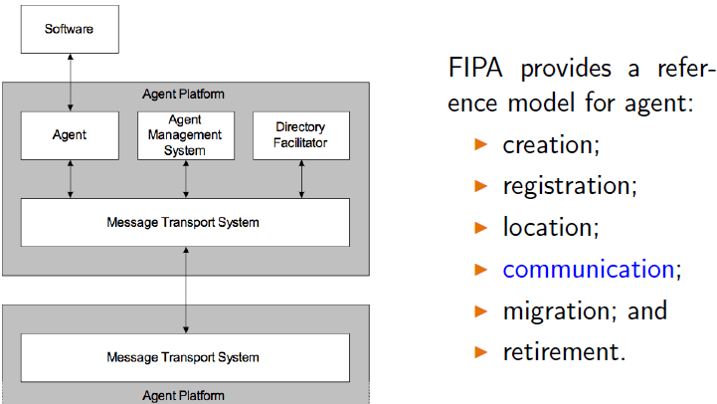

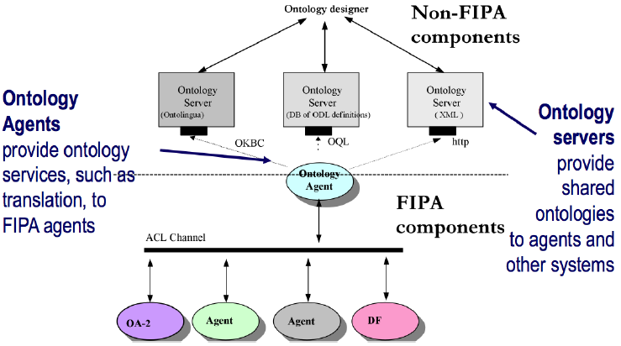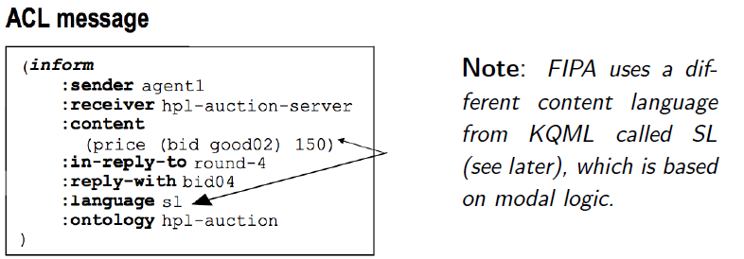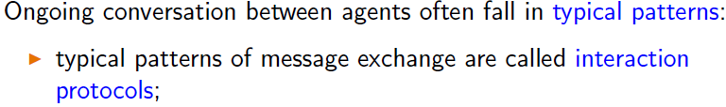

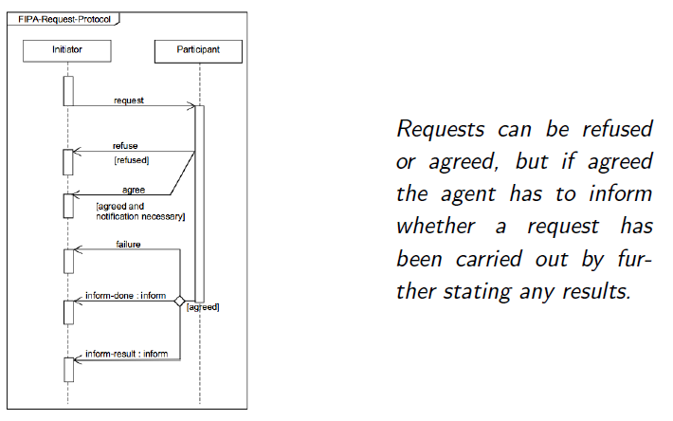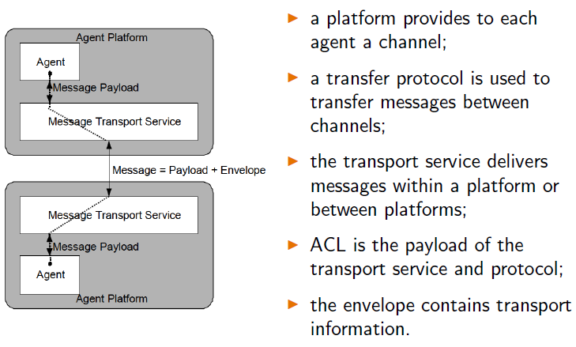

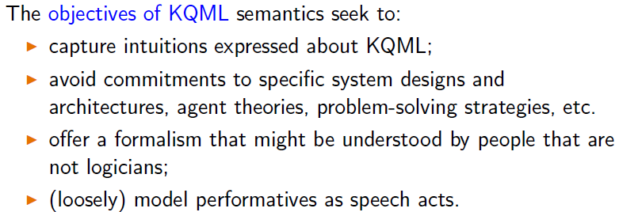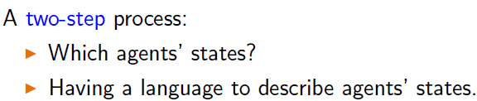

**KQML Way!**

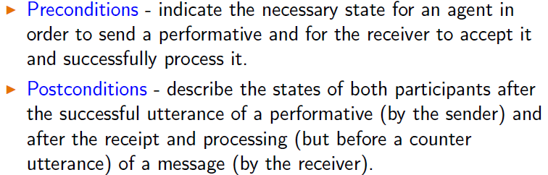

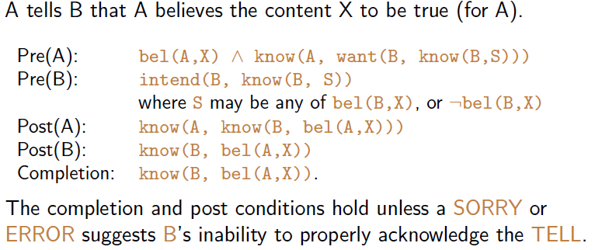

**FIPA ACL Way!**

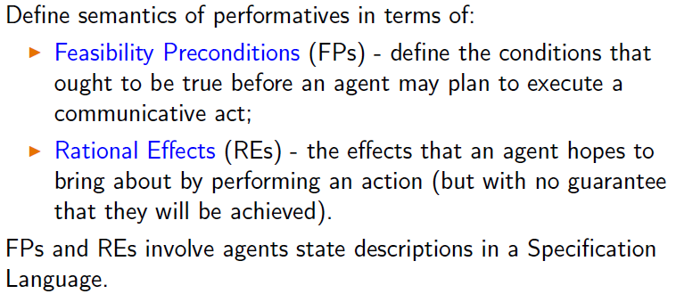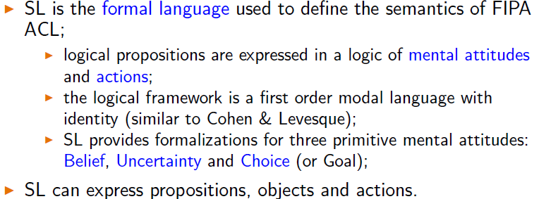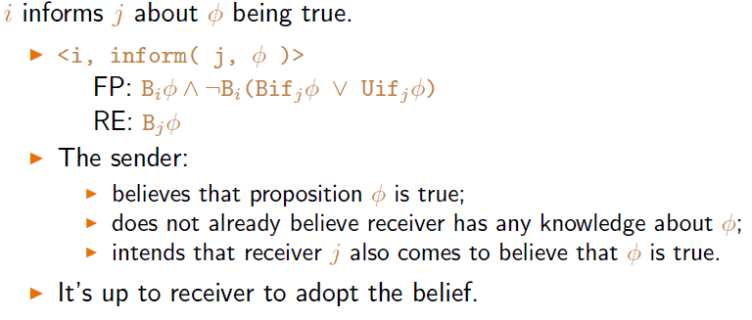

**Comparison between both**

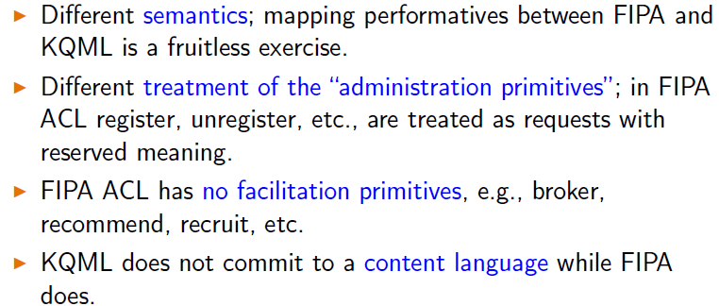

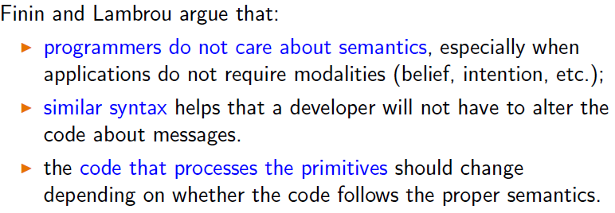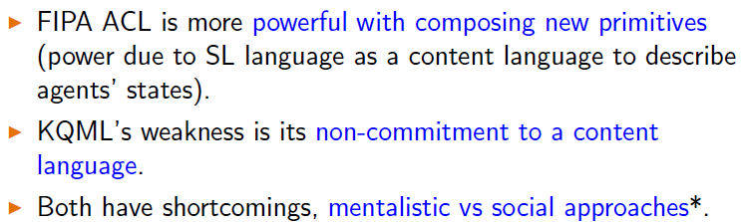

**Multi Agent Systems.**

**No. of agents that:**

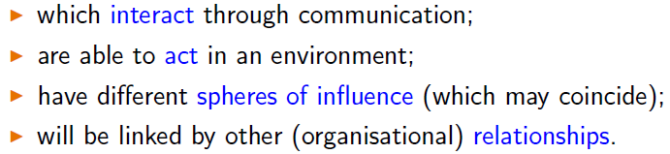

**Single agent = **

**Multi Agent = strategic**

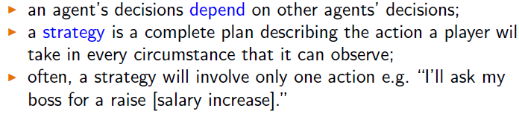

**Utilities and Preferences:**

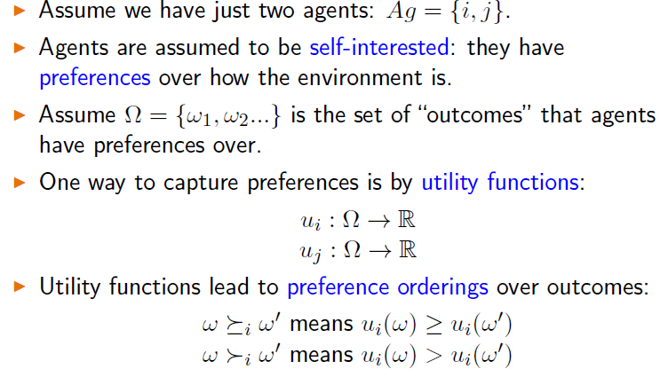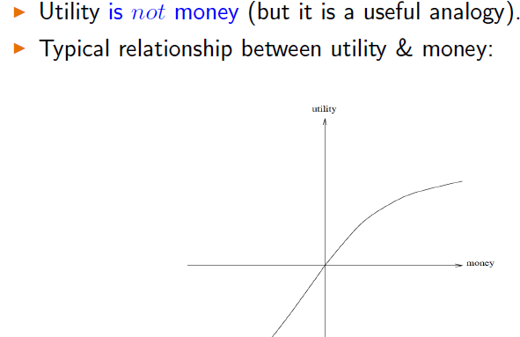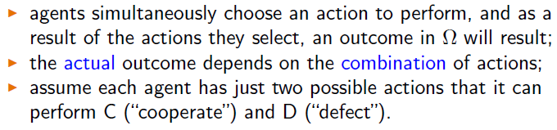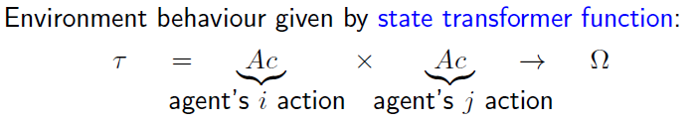

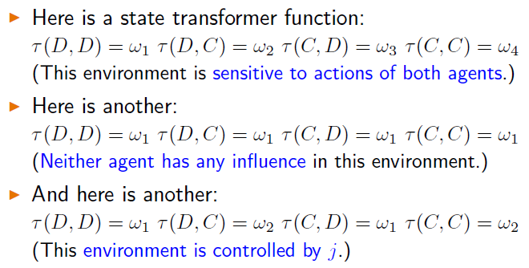

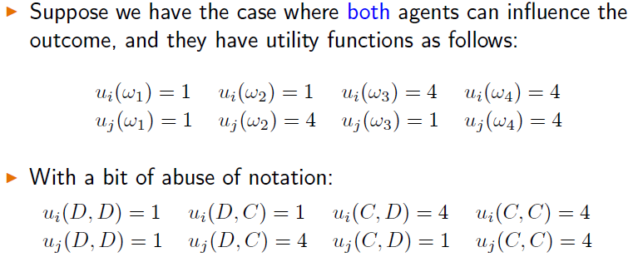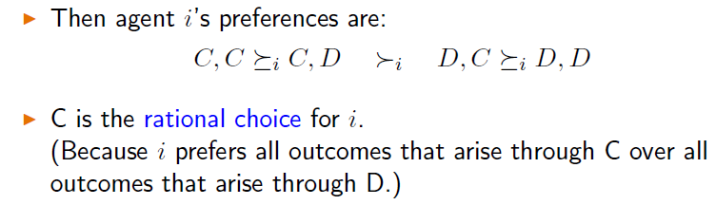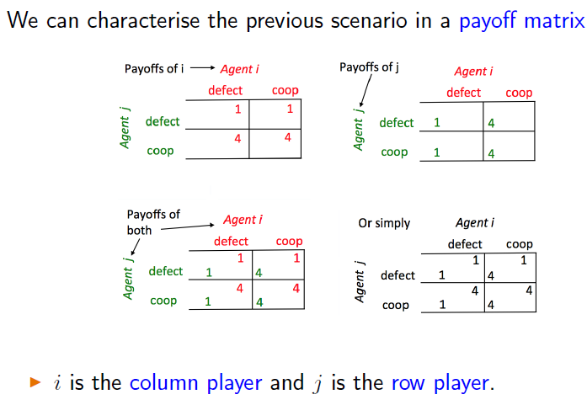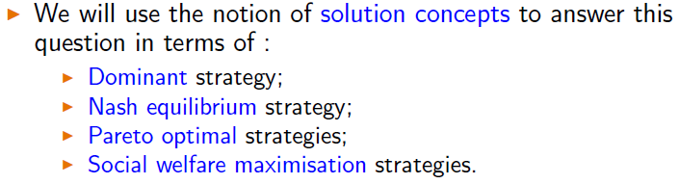

**Dominant Strat**

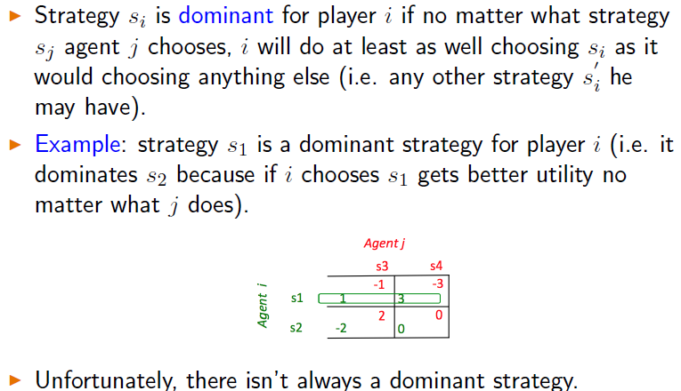

**Nash Strat**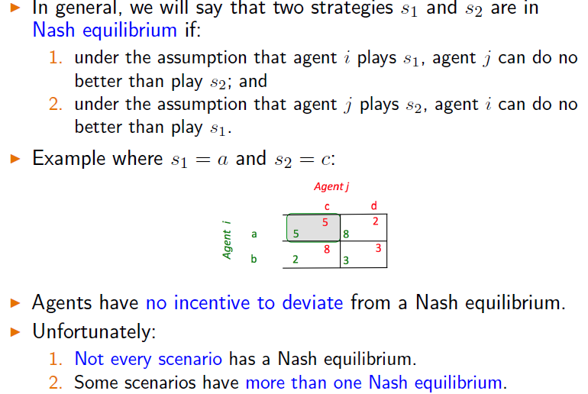

**Mixed Strat**

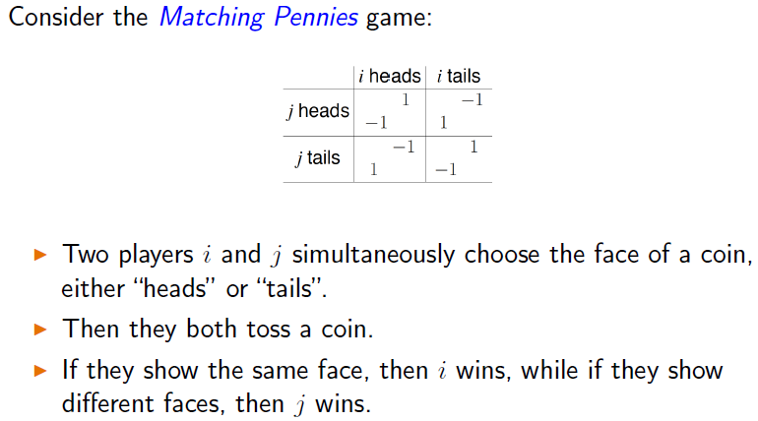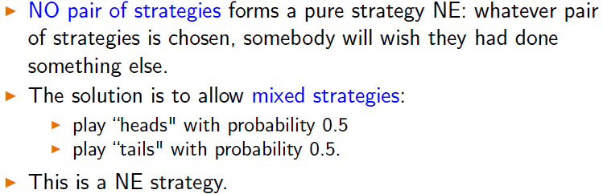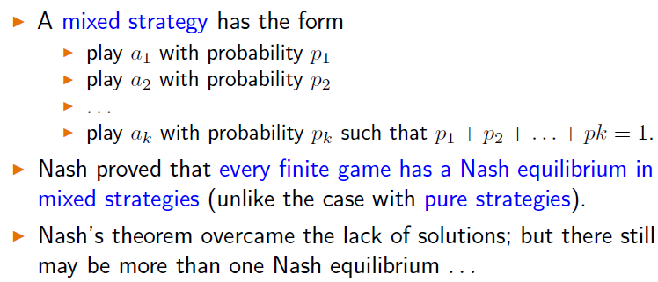

**Pareto Optimality**

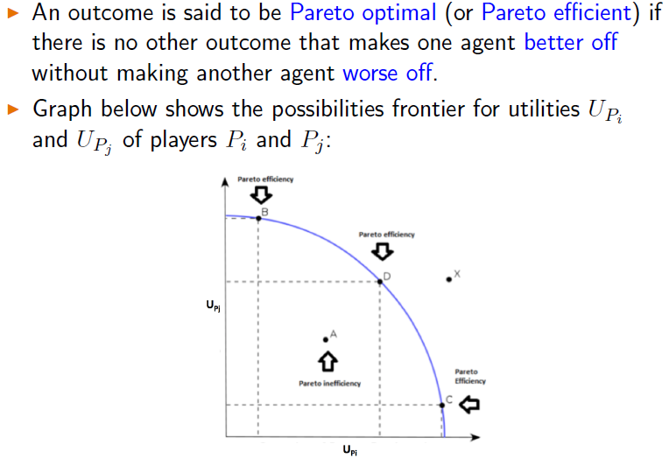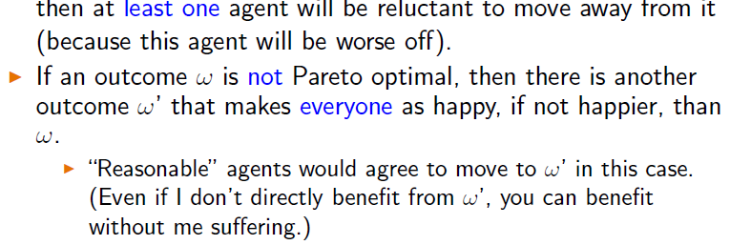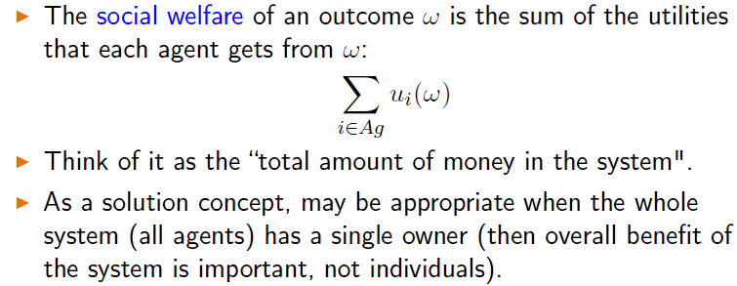

**seldom zero sum game = (ppl acts as if though)**

**zero sum = bad news**

**Prisoner’s Dilemma**

**1 betray = 1 free, 1 = 3 years**

**No betray = both 1 year**

**Both betray = both 2 years**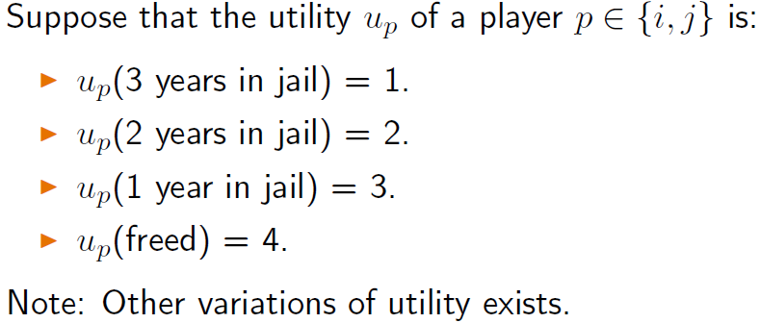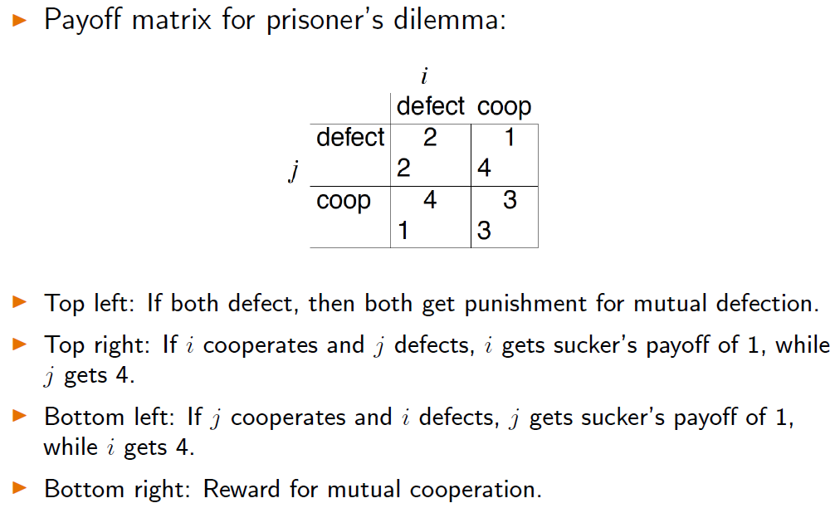

**Individual ration = defect (min of 2 payout, coop has min of 1)**

**NOT the best outcome = both coop (both get 3 payout)**

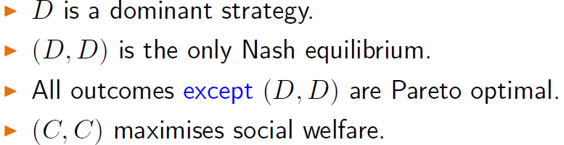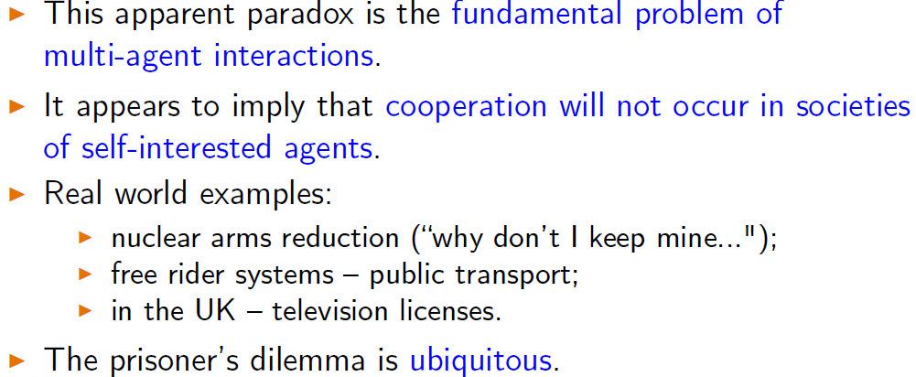

game theory notion of rational action is wrong!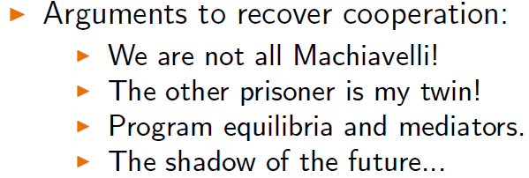

Program Equilibria

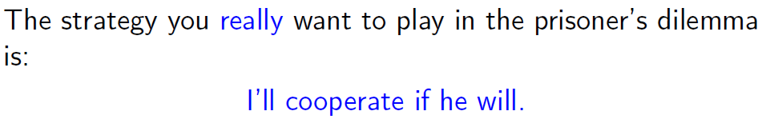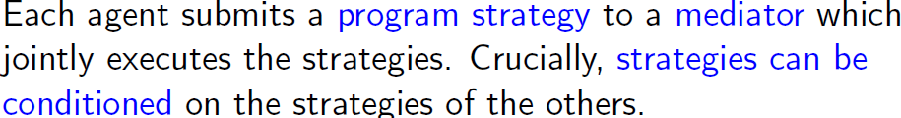

**Conditional strategy**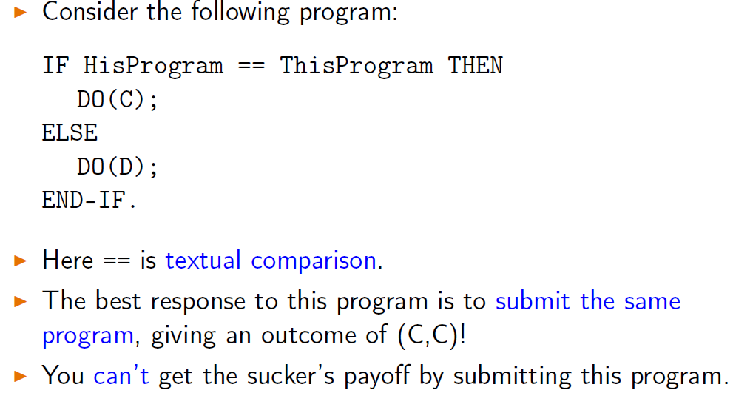

**Iterated (play more than once)** 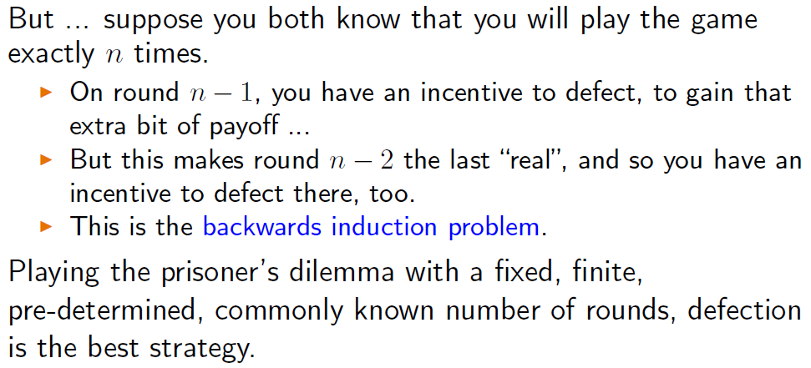

Axelrod’s Tournament (range of opp)

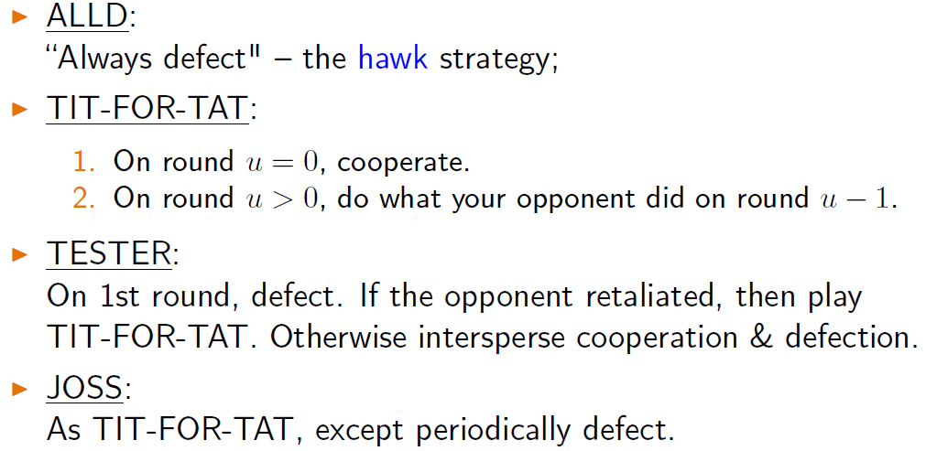

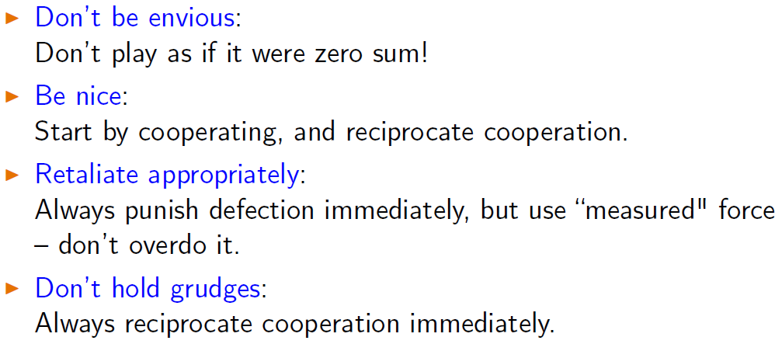

**Game of chicken**

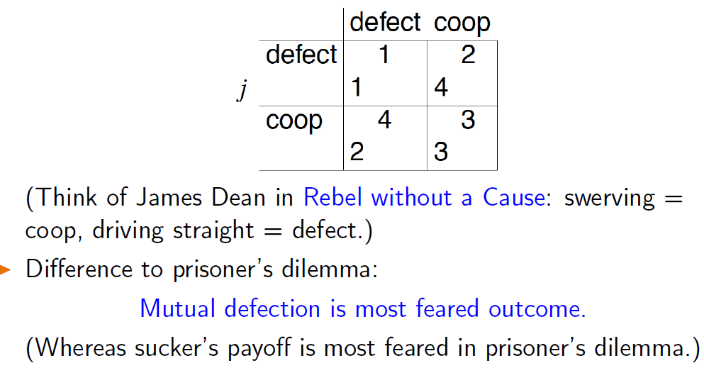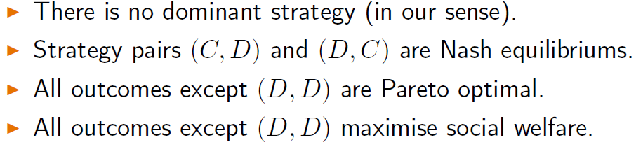

**Negotiation**

reach agreements when they are self interested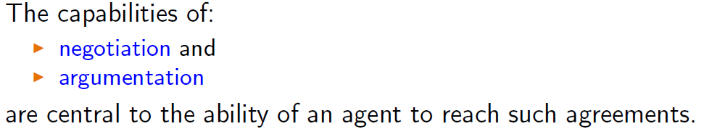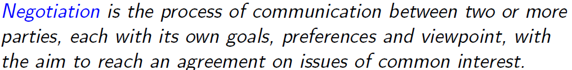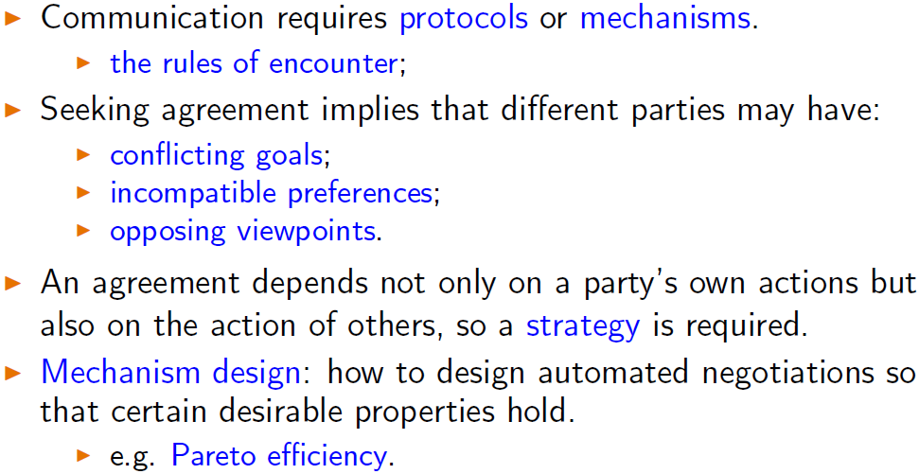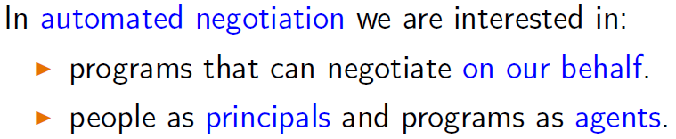

3 components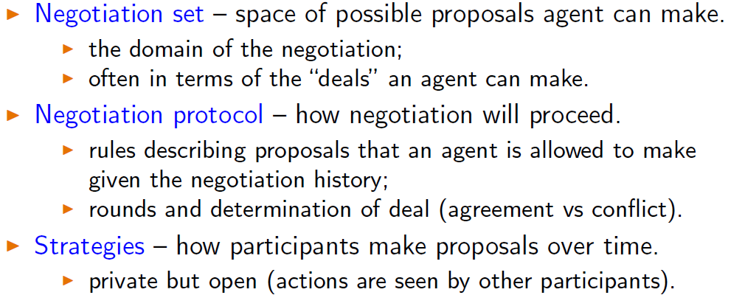

Try to hit win-win

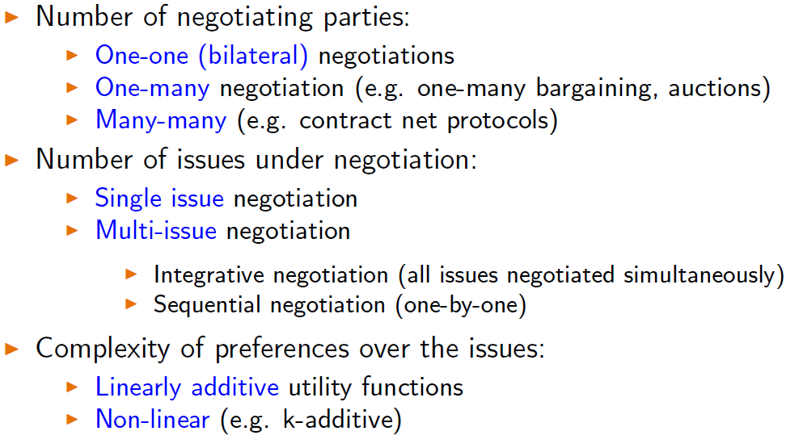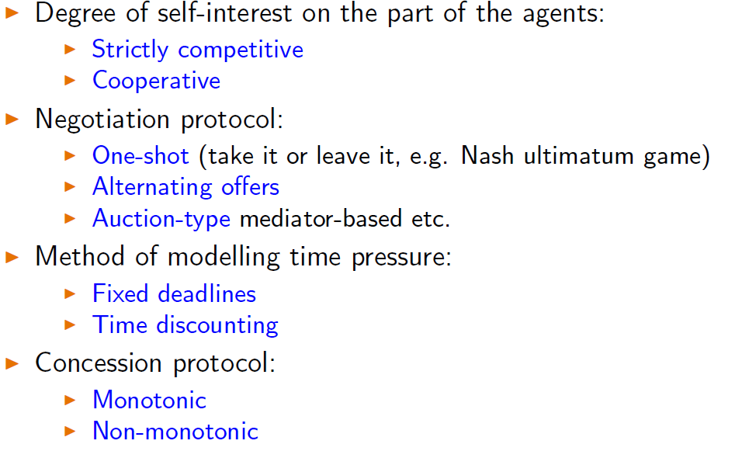

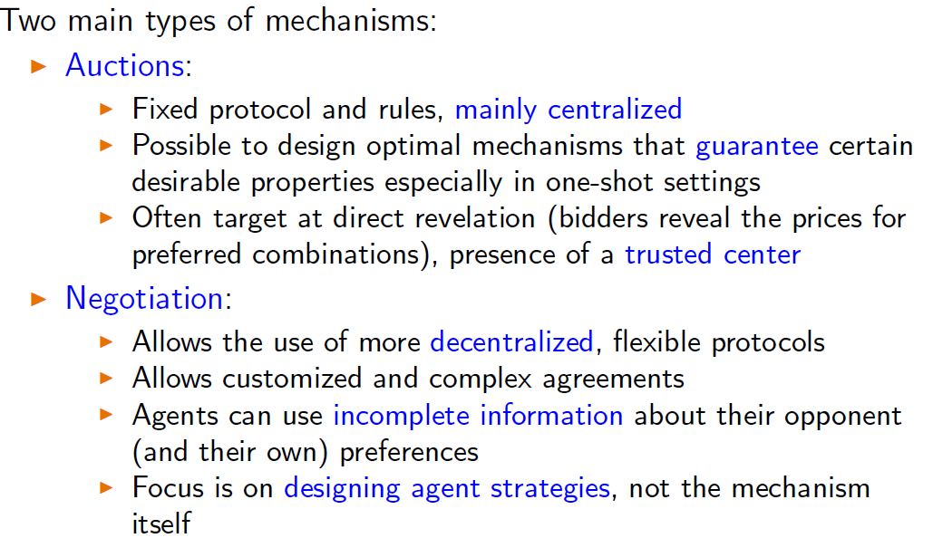

Negotiation approaches

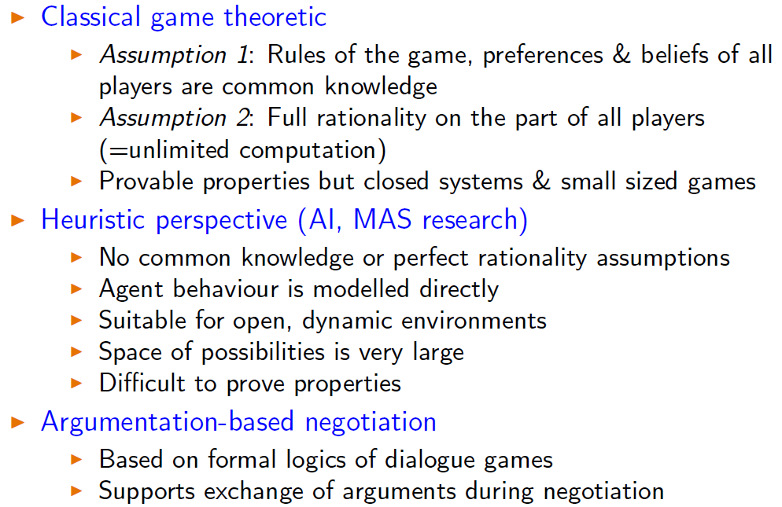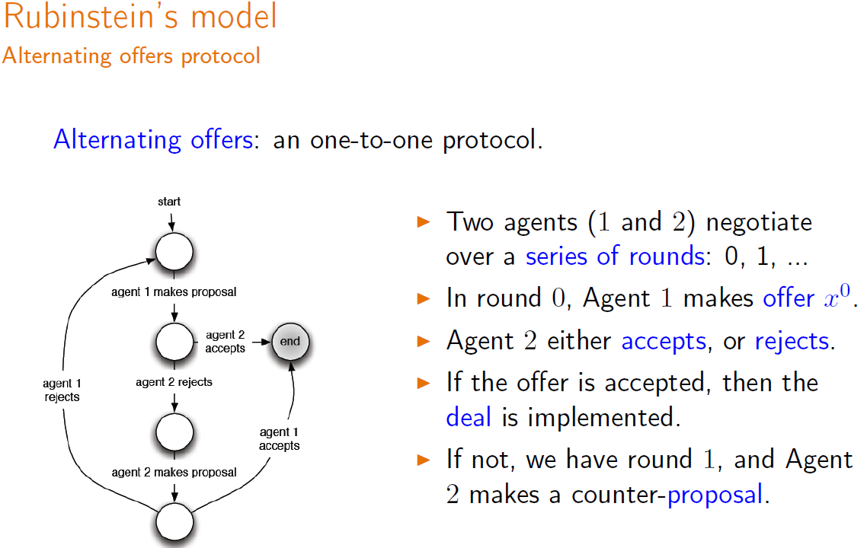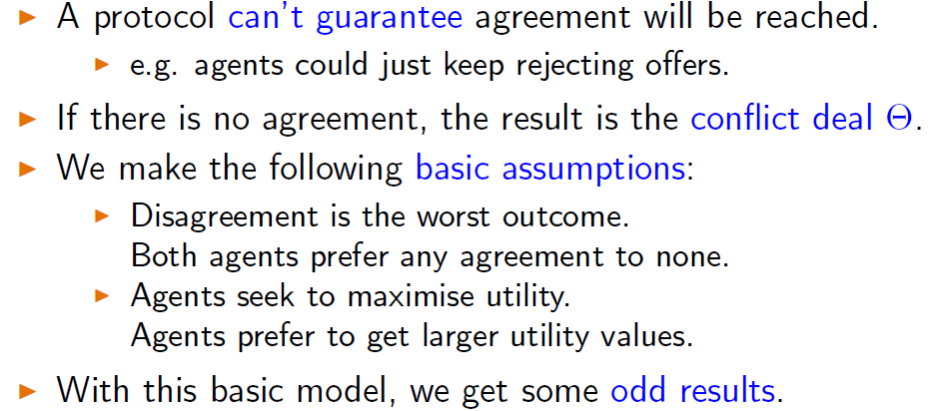

Negotiation for resource division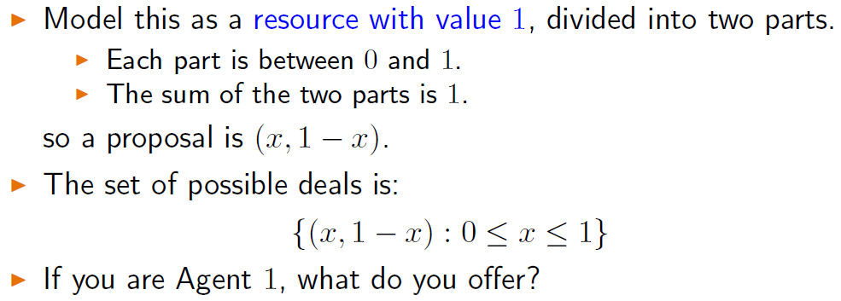

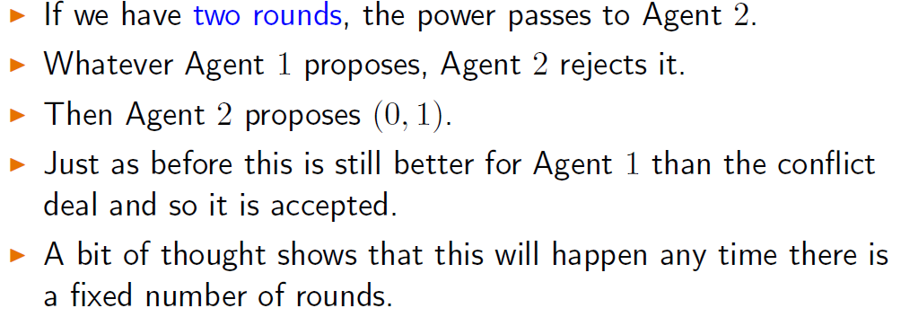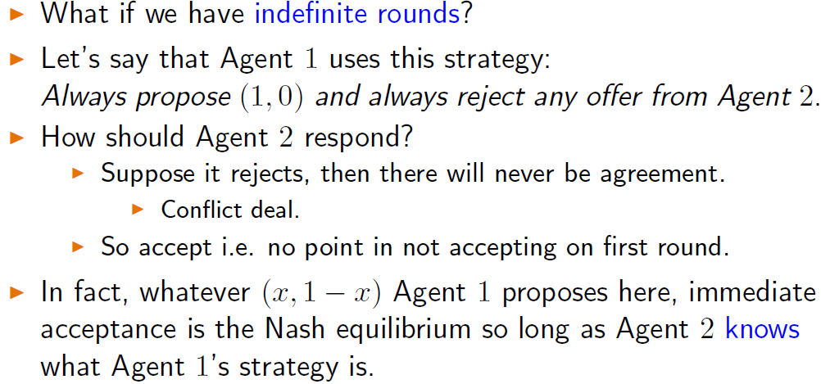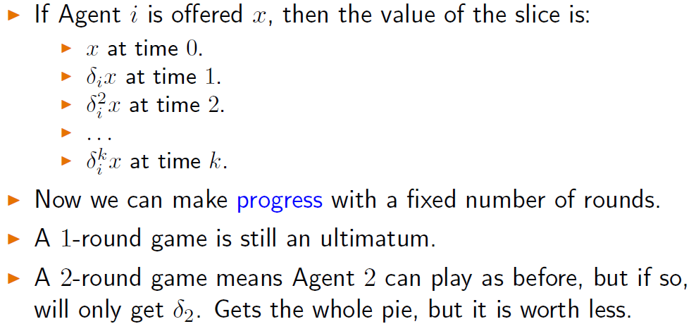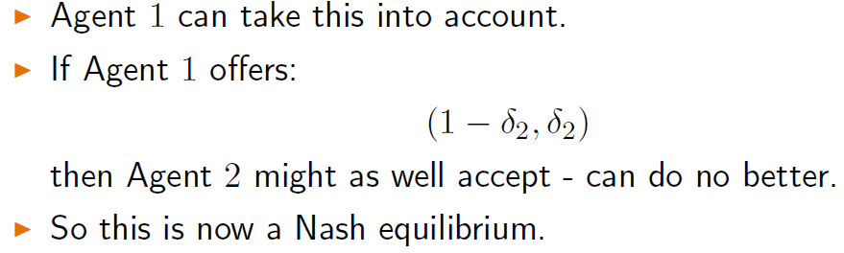

**Heuristic Approach**

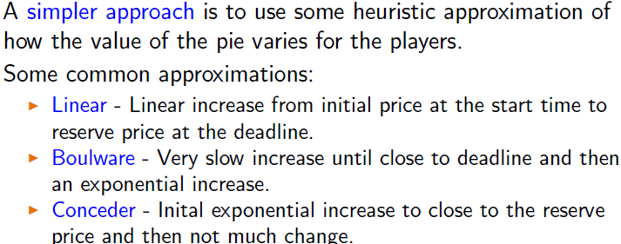

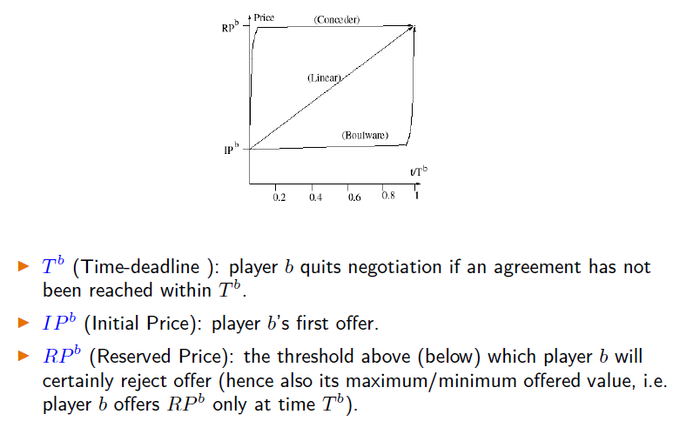

**Task oriented domain**

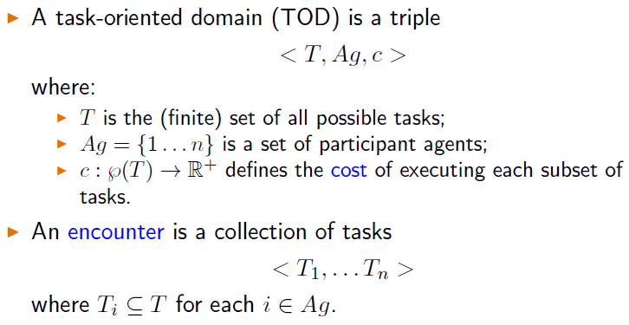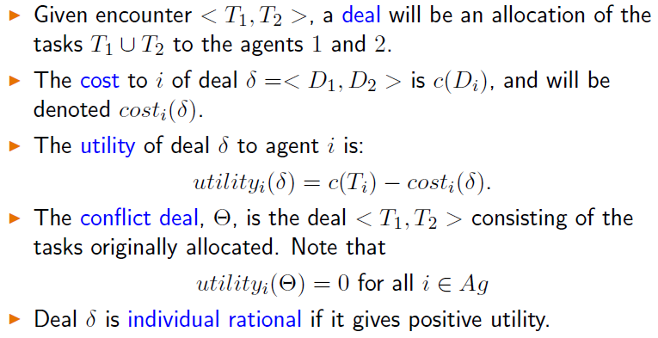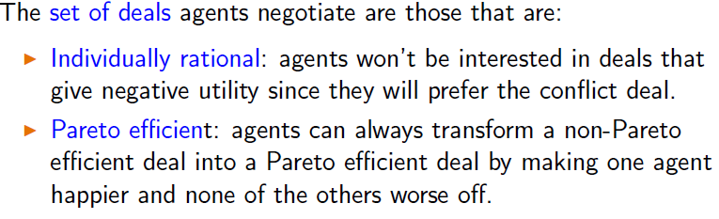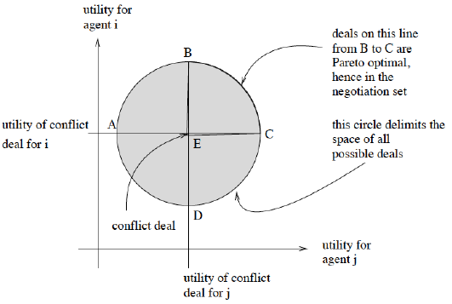

**Monotonic Concession Protocol  
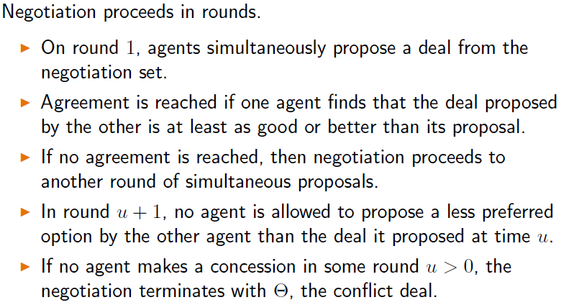**

**Zeuthen Strategy  
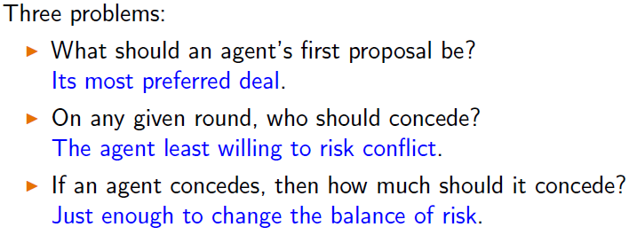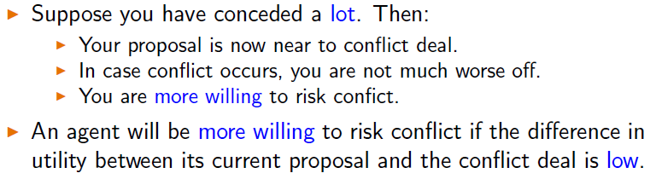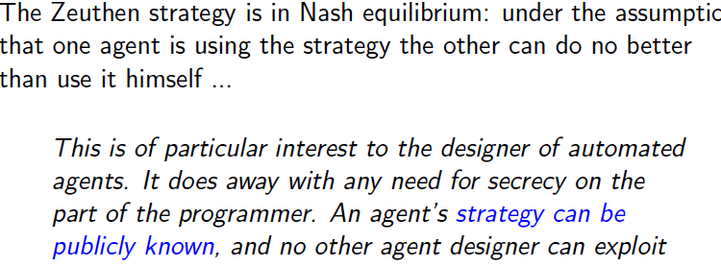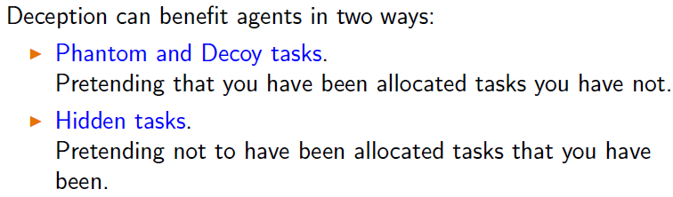**

**Augmentation**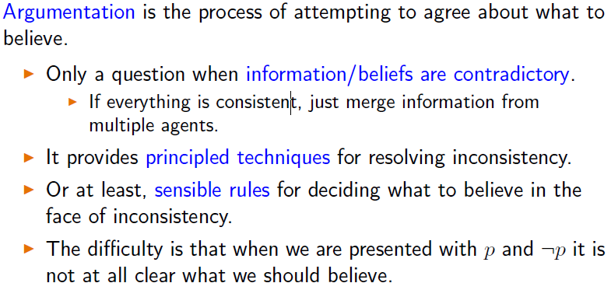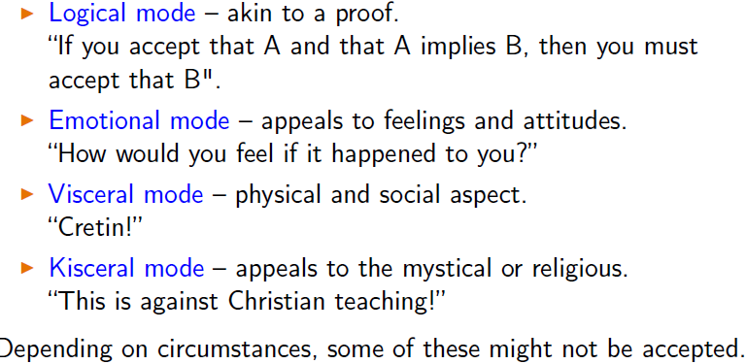

**Abstract Argumentation**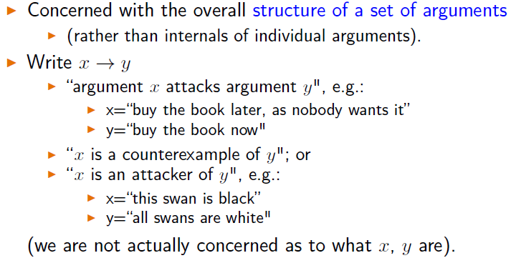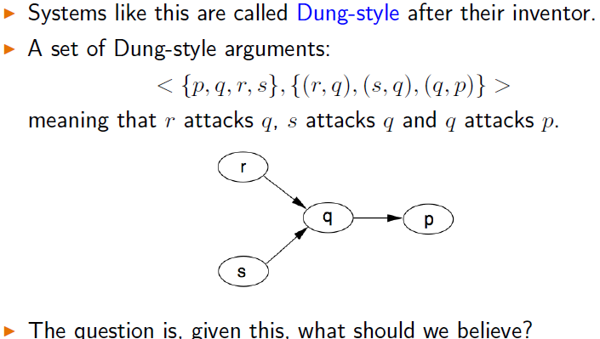

**Internally consistent = what we want**

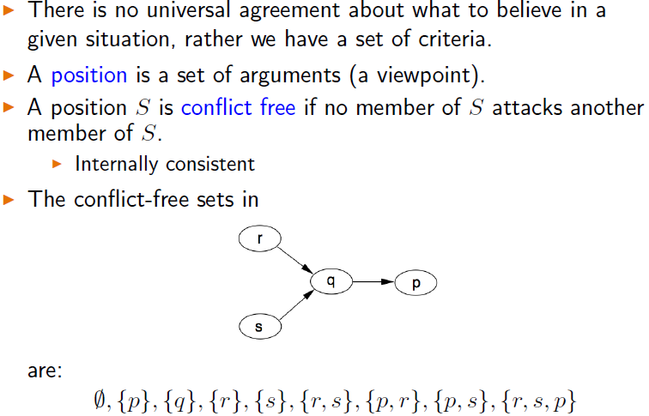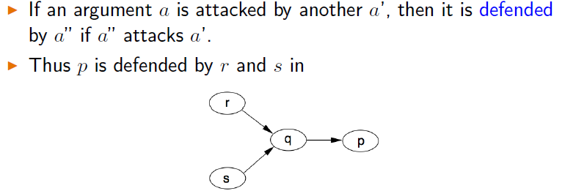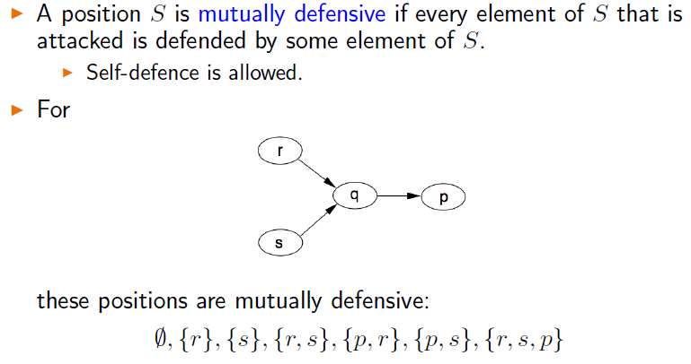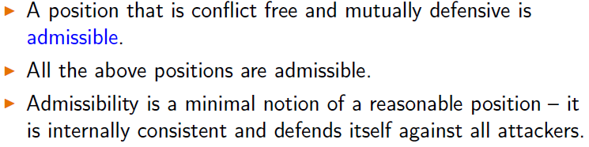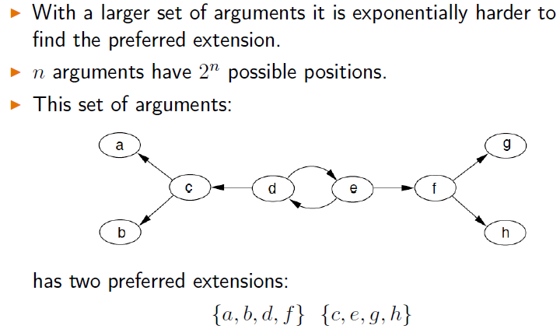

**Aspartix print graph**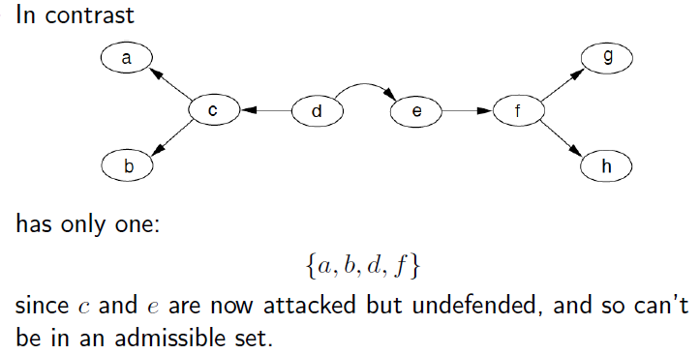

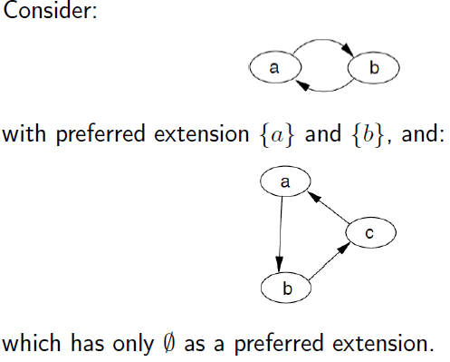

**Credulous and Skeptical acceptance**

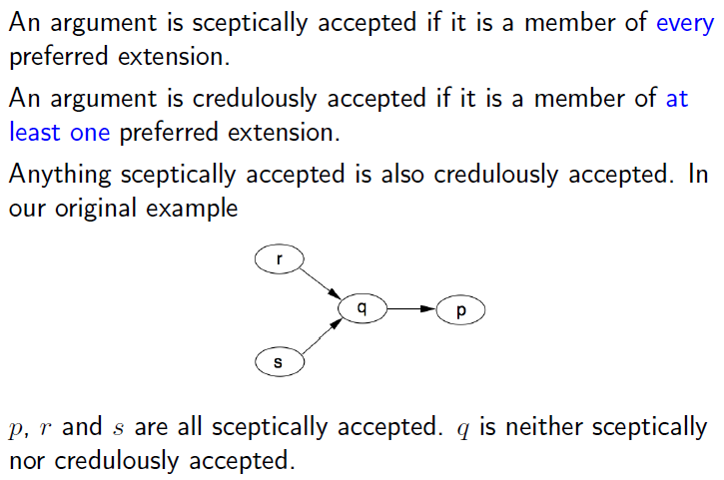

**No attacks to the argument**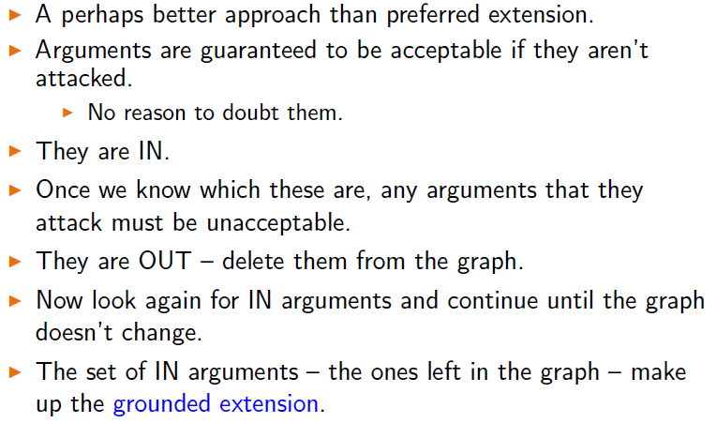

**Deductive Argumentation**

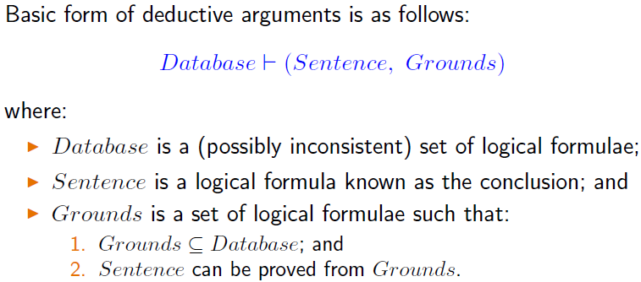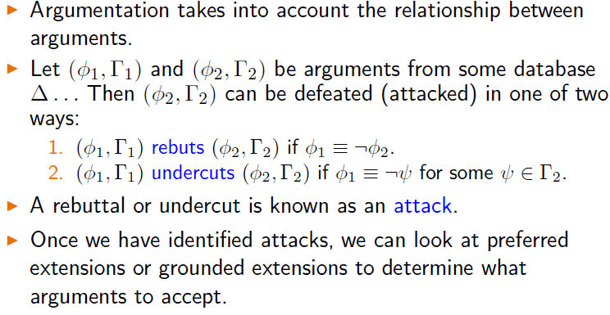

**Argumentation Dialogues**

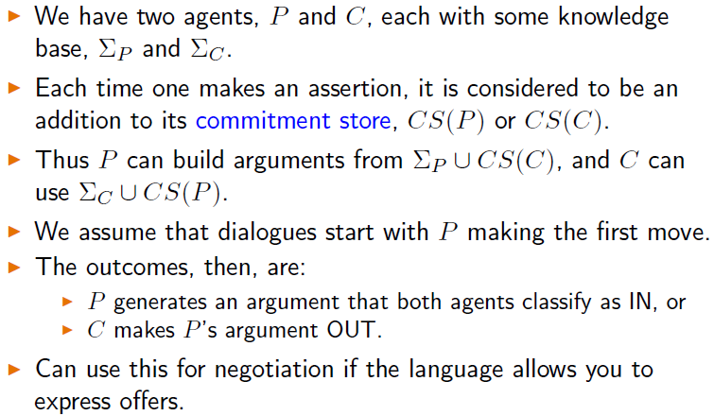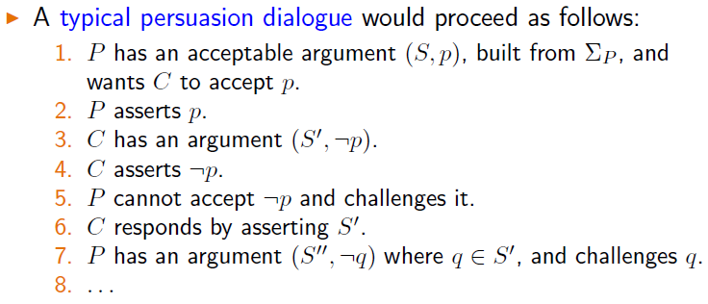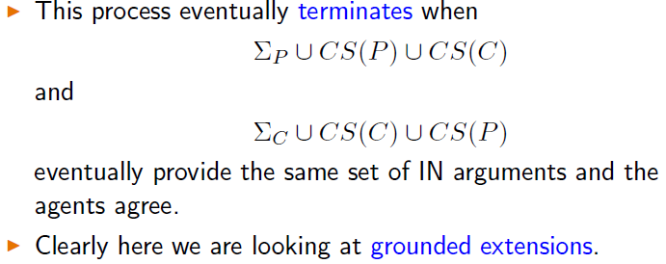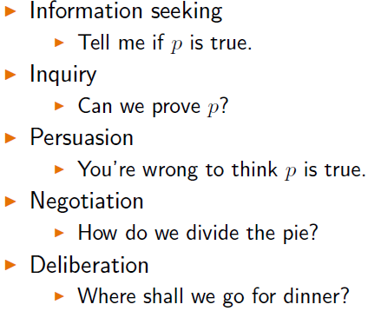

**Methodologies**

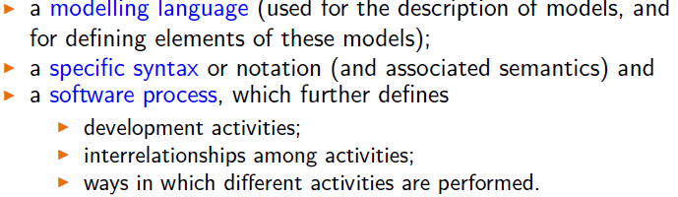

**Idea = inspired by knowledge community**

**Agent orientated approach (define methodology)**

**Object-oriented technique**

**Knowledge engineering Approach (commonKADS)**

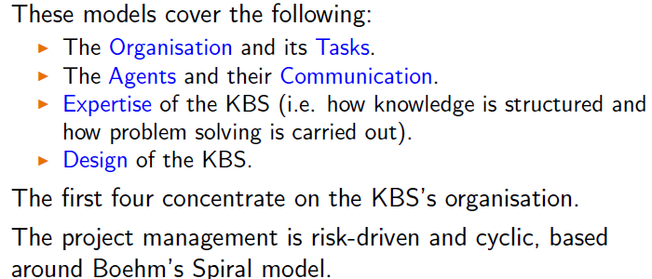

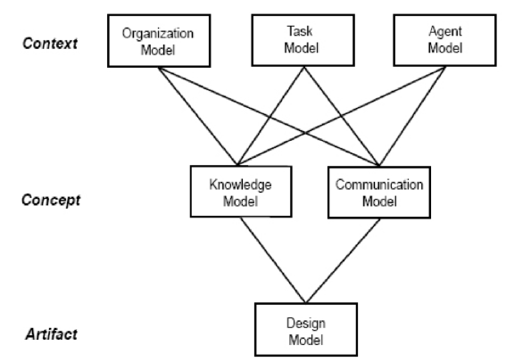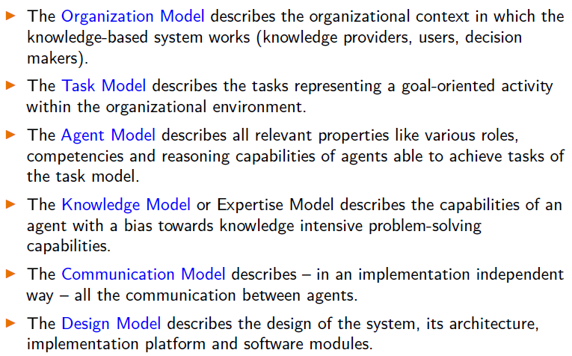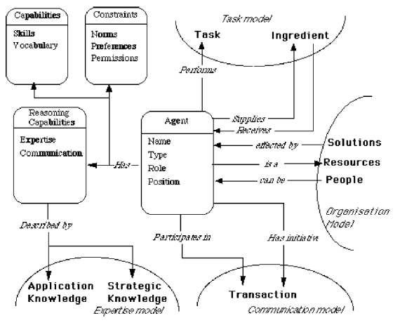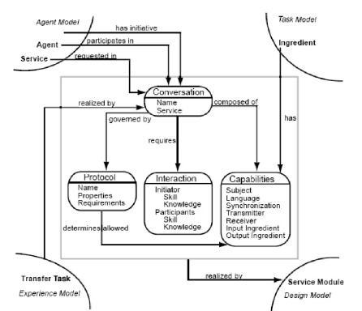

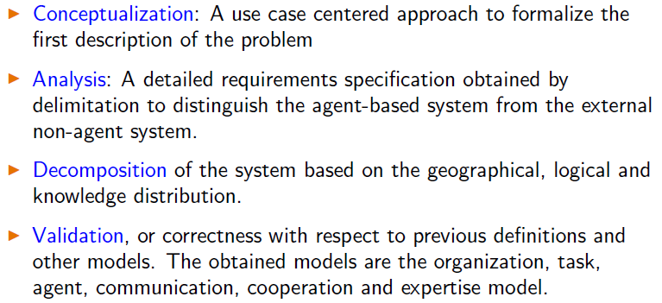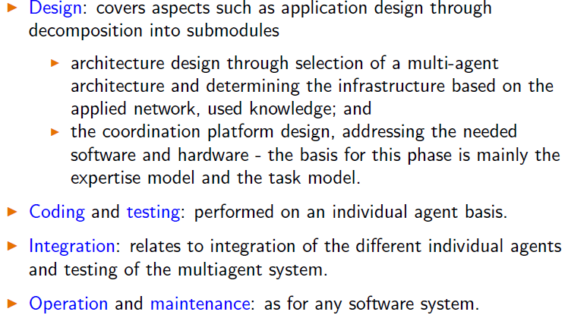

**Object oriented approach**

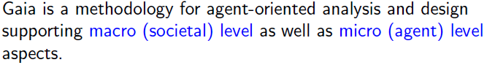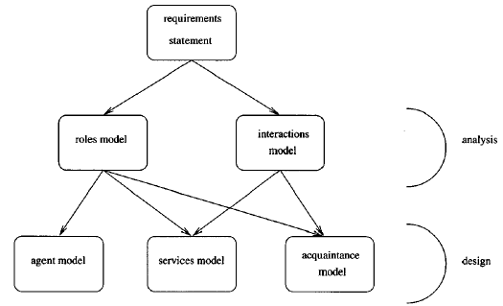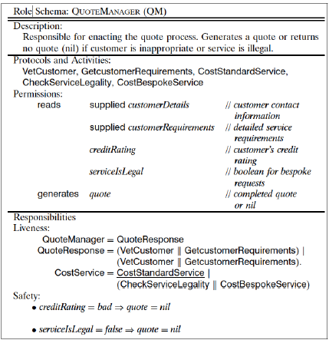

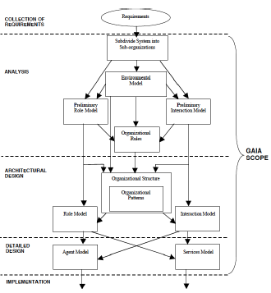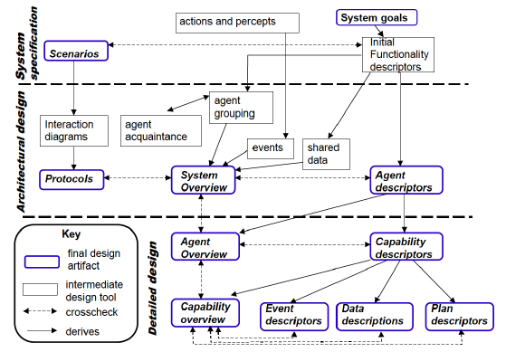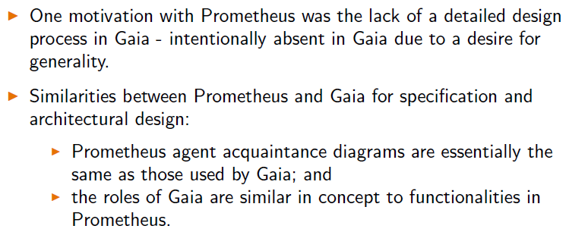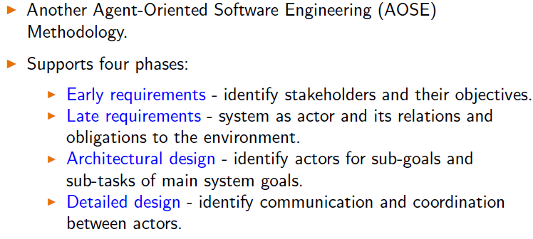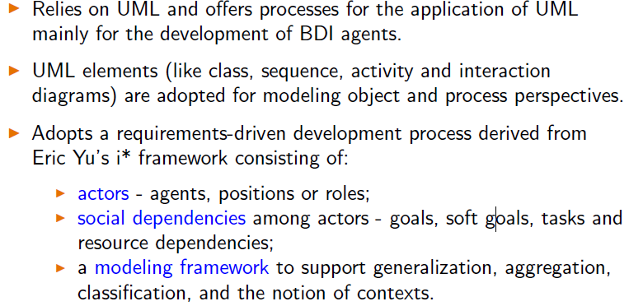

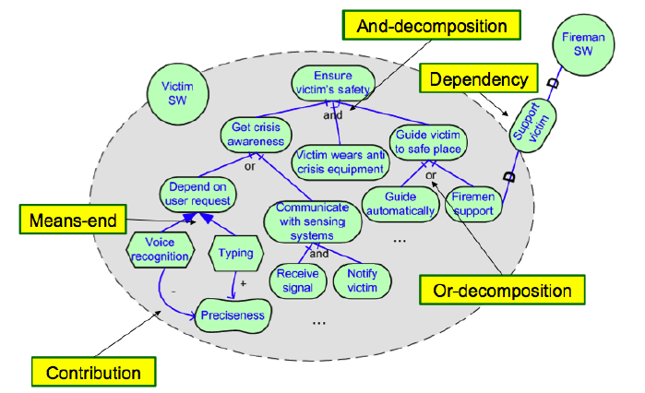

**MAXIMS**

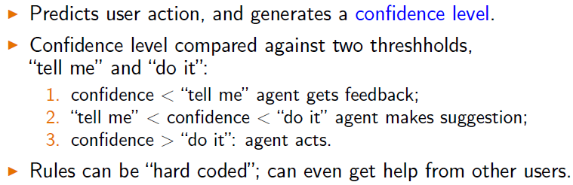

**Jango (e-commerce agent)**

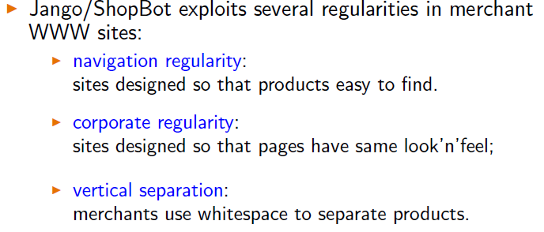

**Nutech and Air Liquefied instrustrial gases**

**Magenta Tech and Tankers**

Can accommodate to large amount of states,

Use performance indicators